All sessions in Peninsula I & II
(please note this is the usual room on the same floor as the hotel lobby near the entrance)

Thursday Afternoon, May 8, 2025
16:00 -16:15 | Introduction and Welcome  to Cabo XXXIII |  | Ian Wilson and Andrej Šali
16:15-17:45 | Short Presentations (4 + 1 min.) by TSRI Graduate Students  (Chair: Keren Lasker, TSRI)
 | Lauren Alexandrescu | TSRI | Towards time-resolved cryo-EM of macromolecular machines
 | Alexandra Salazar | TSRI | High resolution structure determination directly from mitochondrial lysate using cryo-electron microscopy
 | Olivia Swanson | TSRI | Leveraging CryoEM to inform design of de novo proteins
 | Sharidan Brown | TSRI | Anti-immune complex antibodies are elicited after repeated immunization with HIV Env immunogens
 | Simeon Babarinde | TSRI | Structural characterization of small molecule inhibitors with influenza A hemagglutinin
 | Jason Germain | TSRI | In-situ antibody characterization on the surface of Plasmodium sporozoites via cryo-electron tomography
 | Niccolo Bruciaferri | TSRI | Exploring new algorithms for flexible docking
 | Ishan Taneja | TSRI | AlphaFold-RandomWalk: A novel machine-learning based approach to probe protein conformational heterogeneity
 | Elva Ye | TSRI | Proteome wide covalent ligand discovery in brain cells
 | Michael Siroky | TSRI | Engineering AAV to package RNA
 | Leigh Sewall | TSRI | Rapid and high-throughput imaging of immune complexes using microfluidics
 | Brandon Ng | TSRI | Chemoproteomic identification of druggable codependencies in KRAS driven cancers
 | Priyadarshini Chatterjee | TSRI | Pharmacological activation of protective IRE1/XBP1s signaling to reduce systemic inflammation in LPS-induced mouse models
 | Benjamin Thomas, Jr | TSRI | IL-27 enhances CAR-T cell persistence and function in in vivo tumor model
 | Chavin Buasakdi | TSRI | Pharmacological intervention of NLRP3 inflammasome activation and signaling via PDIA1 targeting
17:45-18:00 | Break
18:00-19:00 | Short Presentations (4 + 1 min.) by UCSF Graduate Students and Postdocs  (Chair: Keren Lasker, TSRI)
 | Javarcia Ivory | UCSF | Modulators of lytic transglycosylase activity: nanobodies and bulgecin’s barriers
 | Anna Hatstat | UCSF | Engineering bacterial signal transduction
 | Catherine Sue | UCSF | Mapping the nuclear pore complex assembly pathway and its evolution
 | Kevin Delgado-Cunningham | UCSF | Exploring the interactions of B cell receptors and coreceptors
 | Sara Casebeer | UCSF | Understanding the molecular mechanism of viral CD47 homologs
 | Daphne Chen | UCSF | Enzymatic inhibition of CRISPR-Cas via ADP-ribosylation
 | Jonathan Zhang | UCSF | Dissecting allosteric regulation in small GTPases with high-throughput biochemistry
 | Karen Zhang | UCSF | Isolation and characterization of phage defense systems from environmental bacteria
 | Zi Wei Yao | UCSF | Identifying and targeting KRAS-induced peptide-HLA complexes
 | Alexander Long | UCSF | Small but mighty: SVIP breaks p97's nucleotide-dependent conformational switching
19:00 | Break
19:15– 20:15 |  | Neurobiology |  | (Chair: David Eisenberg, UCLA)
19:15 | Daniel Southworth | UCSF | Structural basis of tau fibril conformations in neurodegenerative disease
19:35 | Oliver Bracko | Frost Inst | Small and mighty: brain capillaries in health and disease
19:55 | Giordanno Lippi | TSRI | Mechanisms of neuronal gene expression
20:30 – 22:30 | Reception with Buffet  (open to all including guests) |  |  | Poolside (adult pool)

Keynote Lecture

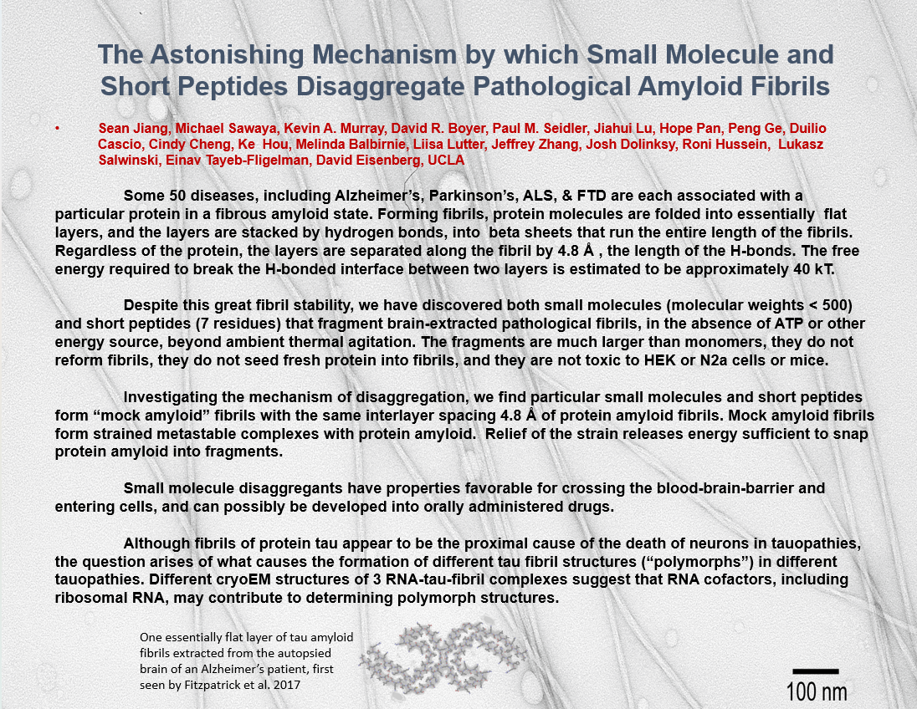

Friday Morning, May 9, 2025 Biophysics and Biology of Cellular Processes I
(Chair: Megan Ken, TSRI)
 | 08:30 | Zev Gartner | UCSF | Directing the self-organization of better models of human tissues
 | 08:50 | Joseph Ferrara | Rigaku | Electron density topography: current status and new results
 | 09:10 | James Williamson | TSRI | Inhibition of ribosome assembly in vitro and in cells
 | 09:30 | Break
Friday Morning, May 9, 2025 Keynote Lecture
(Introduction: Robert Stroud, UCSF)
 | 10:00 | David Eisenberg | UCLA | The astonishing mechanism by which small molecule and short peptides disaggregate pathological amyloid fibrils
 | 11:00 | Questions & Discussion
 | 11:15 | Break
Friday Morning, May 9, 2025 Biophysics and Biology of Cellular Processes II
(Chair: Megan Ken, TSRI)
 | 11:40 | Keren Lasker | TSRI | Condensate engineering
 | 12:00 | Luke Wiseman | TSRI | Pharmacologic targeting of proteostasis
 | 12:20 | Seth Shipman | UCSF | Analog molecular recording
 | 12:40-16:00 | Break
Friday Afternoon, May 9, 2025 Chemistry and Biology
(Chair: Laura Kiessling, MIT )
 | 16:00 | Ahmed Badran | TSRI | Expanding the chemical space of cellular protein translation
 | 16:20 | Matthew Bogyo | Stanford | Covalent chemistry: applications for imaging and therapeutics
 | 16:40 | Philip Dawson | TSRI | Chemical protein synthesis, past, present and future
 | 17:00 | Ronald Raines | MIT | Chemical biology of peptides and proteins
 | 17:20 | Group photo |  | Main lobby steps to pools
 | 17:50 | Dan Santi | UCSF | Long-acting anti-obesity peptides
 | 18:10 | James Wells | UCSF | Extracellular targeted protein degraders, eTPD
 | 18:30 | Margaux Pinney | UCSF | High-throughput protease enzymology reveals mechanisms of hyperactivity, specificity, and resistance
 | 18:50 | Dorothee Kern | TSRI | The protein dance – from experiments to AI predictions
 | 19:10 | Balyn Zaro | UCSF | Ninhydrin is a covalent warhead selectively engaging proteinaceous arginine residues
 | 20:00 – 22:30 Sponsors Dinner, by invitation only – El Agave
Saturday Morning, May 10, 2025 Integrative Computational and Structural Biology
(Chair: Dorothee Kern, TSRI)
 | 08:30 | Andrej Šali | UCSF | Integrative structural biology
 | 08:50 | James Fraser | UCSF | Statistical structural biology
 | 09:10 | William Degrado | UCSF | De novo protein design
 | 09:30 | Stefano Forli | TSRI | Where proteins meet lipids: A deep dive into ligand membrane binding
 | 09:50 | Arthur Olson | TSRI | Visualizing and interacting with the molecular cell
 | 10:10 | Break
Saturday Morning, May 10, 2025 Microbial Pathogens, Immune System, Glycobiology
(Chair: Mark Yeager, The Frost Institute)
 | 10:30 | Andrew Ward | TSRI | Antibody discovery using cryoEM and AI tools
 | 10:50 | James Paulson | TSRI | Adaptation of influenza virus to human airway receptors
 | 11:10 | Laura Kiessling | MIT | Glycans in health and disease
 | 11:30 | Yuzhong Liu | TSRI | Microbial hosts as a biosynthetic platform to accelerate (un)natural product discovery
 | 11:50 | Ian Wilson | TSRI | Structural insights into antibody responses to mpox
 | 12:10 | Katherine Susa | UCSF | New antibody tools to decipher signaling mechanisms on immune cells
 | 12:30-16:30 | Break
Saturday Afternoon, May 10, 2025 Membrane Proteins
(Chair: Andrew Ward, TSRI)
 | 16:30 | Robert Stroud | UCSF | Membrane transporter targets as focus for drug discovery
 | 16:50 | Daniel Minor Jr. | UCSF | Defense for a toxic environment: Frog saxiphilins in action
 | 17:10 | Daniel Isom | Frost Inst | Harnessing the power of advanced multimodal approaches to GPCR drug discovery
 | 17:30 | Mark Yeager | Frost Inst | Drug discovery of the platelet integrin alphaIIb beta3
 | 17:50 | Break
Saturday Afternoon, May 10, 2025 Membrane Proteins
(Chair: Andrew Ward, TSRI)
 | 18:10 | Kliment Verba | UCSF | Visualizing near membrane signaling with cryo-EM
 | 18:30 | Michael Grabe | UCSF | The heads and tails of lipid interactions with membrane proteins
Sunday Morning, May 11, 2025 Therapeutics, Signaling & Activation
(Chair: James Wells, UCSF)
 | 08:30 | Travis Young | Calibr-Skaggs | Immunotherapy at Calibr-Skaggs
 | 08:50 | Shannon Miller | TSRI | Engineered tools for cell and gene therapies
 | 09:10 | Jonathan Moore | Rectify Pharma | A structural and mechanistic model for BSEP dysfunction in PFIC2 cholestatic disease
 | 09:30 | Patrick Holder | Genentech | Targeted delivery of IL-15 to effector T cells through simultaneous glycan and protein engineering
 | 09:50 | Break
Sunday Morning, May 11, 2025 Nucleic Acids
(Chair: Jamie Williamson, TSRI)
 | 10:10 | Ian MacRae | TSRI | Gene silencing by small RNAs
 | 10:30 | Megan Ken | TSRI | Exploring the structure-function relationship of the HIV 5'-UTR
 | 10:50 | Lorenzo Di Bari | U. Pisa | New insights into the stereochemistry of single stranded oligonucleotides
 |  | Luca Gherardi | U. Pisa | Conformational freedom of single stranded oligonucleotides
 | 11:15 | Andrej Šali & Ian Wilson |  | Closing remarks

In order to protect individual rights and promote discussion, it is a requirement of the Scripps/UCSF CABO Annual Meeting that no information presented is to be used or disclosed without the specific approval of the disclosing party. Each attendee of the Conference agrees that any information presented, whether in a formal talk or discussion, is a private communication from the individual making the contribution and is presented with the restriction that such information is not for public use. Each member of the Conference acknowledges and agrees to these restrictions as a condition of attending the Conference.

Thanks to our sponsors
