Core 1, Project 4: Integration of Spatial and Temporal Data Into Dynamic
Representations of Subcellular Processes
A. SPECIFIC AIMS
A comprehensive structural and dynamic description of proteins, nucleic acids, and their assemblies will help us discover the principles that underlie cellular processes. Our broad objective is to contribute to this effort by continuing to develop and apply a computational system for enumerating structures and trajectories of macromolecular assemblies that are consistent with all available information from experimental methods, physical theories, and statistical preferences extracted from biological databases¹⁻⁶. Such an integrated system will maximize accuracy, resolution, completeness, and efficiency of determining macromolecular assembly structures and the processes in which they participate.
Characterization of static structures is expressed as an optimization problem, requiring a representation of the modeled system, a scoring function that encodes available structural information, and an optimization protocol that delivers good scoring structures. The assembly is defined hierarchically; different parts of the system are represented with different resolutions and spatial restraints can refer to different levels of the hierarchy (eg, restraints on atoms across an interface and subunit contact restraints). The scoring function expresses input information in a common format, ideally as probabilities on spatial aspects of the model (eg, distances, angles, volume, and symmetry). Our existing Integrative Modeling Platform (IMP) software (http://salilab.org/imp) provides a convenient framework for implementation of the proposed restraints and sampling schemes.
Specific Aim 1: Develop spatial restraints on the structure of a given assembly that encode experimental data, physical theories, and statistical inferences.
To support the modeling of biological systems studied in NCDIR, we need to enrich the current library of restraint types. We will develop the following three types of restraints: First, an atom-atom distance restraint derived from chemical cross-linking, explicitly representing the cross-linker and the restrained proteins at atomic resolution. Second, a restraint on the relative orientation of two protein structures, based on an ensemble of solutions calculated by molecular docking¹²⁻¹⁴ or comparative modeling¹⁷. Third, a restraint on the relative orientation of two protein structures, based on affinity purification data from domain deletion constructs.
Specific Aim 2: Develop methods for sampling static structures of an assembly that satisfy a given set of spatial restraints.
We propose a new divide-and-conquer optimization framework for efficiently producing an ensemble of models that minimizes the scoring function encoding the restraints. First, the set of degrees of freedom to be optimized is decomposed into smaller relatively uncoupled subsets. Second, the subsets are optimized independently from each other by a traditional optimizer, producing the optimal and nearly optimal solutions. Third, the individual subset solutions are gathered into the best possible solutions for the complete set of degrees of freedom. Graph theory provides efficient algorithms for decomposition and gathering.
Specific Aim 3: Develop methods for sampling trajectories of a given macromolecular system that are consistent with input information about its structures and dynamics.
We propose two efforts on extending modeling by satisfaction of spatial restraints from determining static structures to temporal modeling of processes. The first approach is based on coarse-grained Brownian dynamics simulations using forces and representations derived from experimental data. The second approach builds a graph model of the whole process directly from the data; as for the static structure case, the approach relies on model representation, model scoring, and searching for good models.
The proposed computational methods are essential for integrative structure determination of systems studied by NCDIR (Core 2), using data generated with NCDIR technologies (Core 1, Projects 1-3). In return, the development of our computational methods will benefit from the inevitable challenges, feedback, and validation that real world problems provide to methods developers. It is most important that we demonstrate the applicability of IMP to a spectrum of different types of applications, including spindle pole body, the 26S proteasome, the peroxisome, ribonucleoprotein particles, the interleukin-2 enhanceosome complex, and other chromatin complexes (Core 2). To maximize our impact, the IMP software will be available freely from our web site. In addition, we will offer to host other scientists for short periods of time to train them on how to apply IMP to their chosen problems.
B. BACKGROUND AND SIGNIFICANCE
Complete lists of macromolecular components of biological systems are increasingly becoming available. We now need to explain the functionality of the system as a whole in terms of the properties of its components and interactions between them (Fig. 1). To do so, a comprehensive characterization of the structures and dynamics of macromolecular assemblies is essential^{1,19,20}. In this proposal, we develop and apply computational methods for achieving these two tasks.

B.1 Need for integrative characterization of static structures

Compared to structure determination of the individual components, structural characterization of macromolecular assemblies is usually more difficult and represents a major challenge in structural biology. For example, x-ray crystallography²² is limited by the ability to grow suitable crystals and to build molecular models into large unit cells; Nuclear Magnetic Resonance (NMR) spectroscopy²⁵ is limited by size; electron microscopy (EM), small angle X-ray scattering (SAXS)²⁶, affinity purification²⁷, yeast two hybrid experiments²⁸, calorimetry²⁹, footprinting³⁰, chemical cross-linking³¹, and Förster Resonance Energy Transfer (FRET) spectroscopy³² are limited by low resolution of the corresponding structural information; and computational protein structure modeling³³ and docking³⁴ are limited by low accuracy.
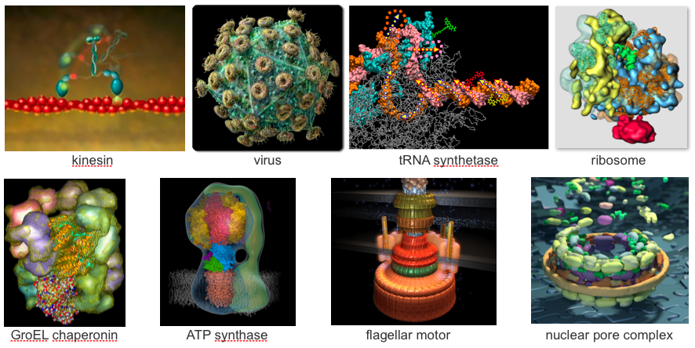
Fig. 1. Example structures of macromolecular machines and processes. Kinesin is a motor protein moving along microtubule cables⁷, HIV virus infects host cells^{8,9}, tRNA synthetase plays a major role in translation during protein synthesis¹⁰, ribosome is the machine that makes proteins as instructed by mRNA¹⁶, GroEL chaperonin catalyzes protein folding¹⁸, ATP synthase utilizes the electrochemical proton gradient to synthesize ATP out of ADP and phosphate²¹, bacterial flagellar motor helps bacteria swim²³, and yeast nuclear pore complex regulates transport of macromolecules between the cytoplasm and the nucleus²⁴. Structures generally facilitate understanding how machines work, how they evolved, how they can be controlled, modified, and perhaps even designed.
These shortcomings can be minimized by simultaneous consideration of all available information about a given assembly (Fig. 2)³⁵. This information may vary greatly in terms of its accuracy and resolution, and includes data from both experimental and computational methods, such as those listed above. Our Center’s strength is the wealth of experimental data it will produce on a given system. However, new methods are needed for computing the structural models of a given complex that are consistent with all available information about its composition and structure. Using varied sources of information can compensate for their individual shortcomings. An example of a simple hybrid approach is building a pseudo-atomic model of a large assembly by fitting atomic structures of its subunits predicted by comparative protein structure modeling into a density map determined by cryo-EM^{2,5,16,36-38}.

B.2 Integrative characterization of static structures as an optimization problem

We have been developing a theory for sampling structural models of a macromolecular assembly that are consistent with all available information (Section C.1; Fig. 3)^{2,3,24}. To achieve this objective, we are applying the formalism of modeling by satisfaction of spatial restraints^{17,39,40.} developed for individual proteins to assemblies of macromolecules. Hybrid structure determination can be formulated as an optimization problem, a solution of which requires three main components: (i) the representation of the assembly; (ii) the scoring function that consists of the individual restraints; and (iii) the optimization method that finds good scoring assembly structures. We propose here to continue developing corresponding methods as well as to generalize the approach so that it can generate models of dynamic processes as well as static structures.
B.3 Need for integrative determination of structural dynamics of macromolecular processes
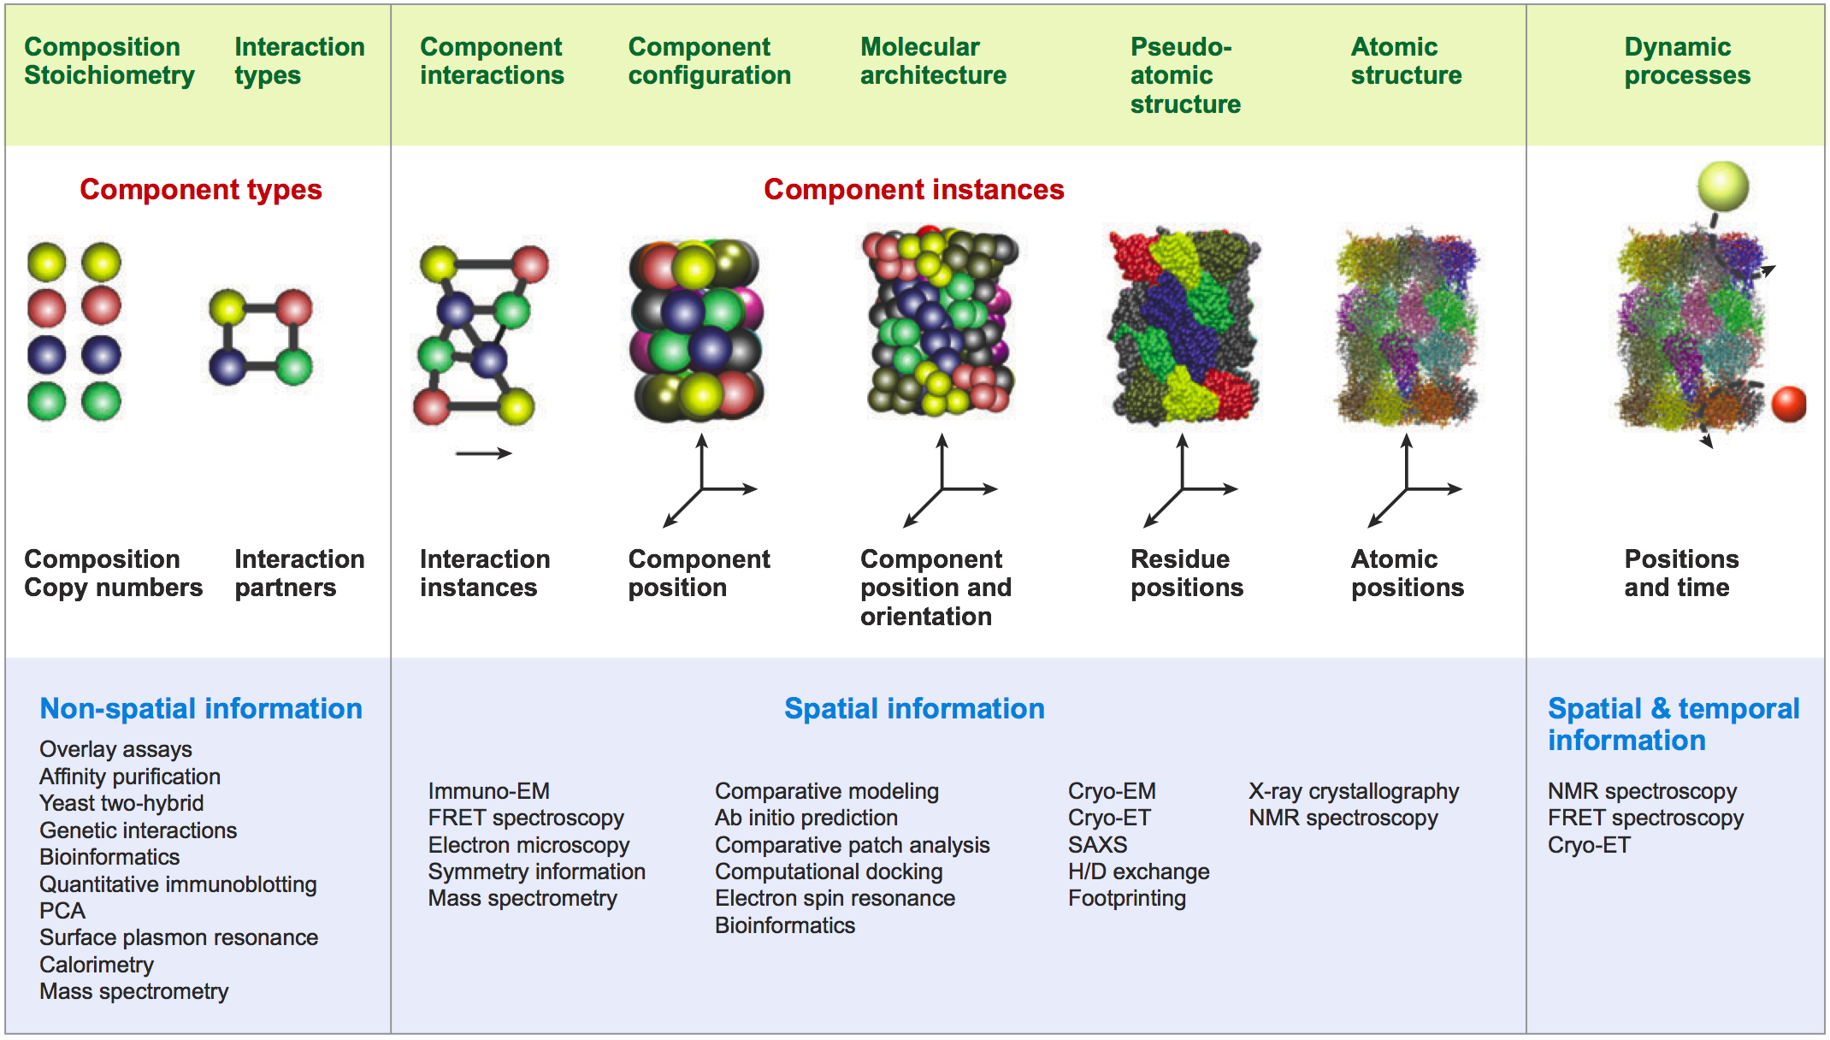
Fig. 2. Structural information about an assembly. Varied experimental methods can determine the copy numbers (stoichiometry) and types (composition) of the components, whether or not components interact with each other, positions of the components, and their relative orientations. Importantly, some methods identify only component types and do not distinguish between different instances of a component of the same type when more than one copy of it is present in the assembly. Other methods do identify specific instances of a component. The structure of even large, complex, and dynamic macromolecular assemblies, such as the nuclear pore complex, can be modeled by integrating enough information on the properties of its components and their interactions. Integration of data from varied methods generally increases the accuracy, efficiency, and coverage of structure determination. PCA, protein-fragment complementation assay; H/D, hydrogen/deuterium, EM, electron microscopy; FRET, Förster resonance energy transfer; SAXS, small angle X-ray scattering.

To understand the cell, we need to describe the structural dynamics of macromolecular processes, not only the static structures of the corresponding assemblies (Fig. 1). These processes take place over a wide variety of time scales from nanoseconds to minutes and on size scales from nanometers to micrometers. The wide range of temporal and spatial scales exceeds the capabilities of existing experimental and simulation techniques. There is a large gap between the microsecond time scale, which simulations are just beginning to reach, the millisecond time scale, where most single molecule and ensemble stopped flow methods start to come into play, and the seconds to minutes scale, where complexes interact and rearrange. Another key challenge is bridging the gaps between the resolutions of x-ray crystallography (atomic), single particle EM (1–3 nm), electron tomography (4–10 nm), and light microscopy (30 nm). And just as structural heterogeneity of an ensemble complicates static structure determination, heterogeneity in event times and in the ordering of events complicates the experimental approaches for collecting the data and theoretical frameworks for describing these processes^{41,42}.
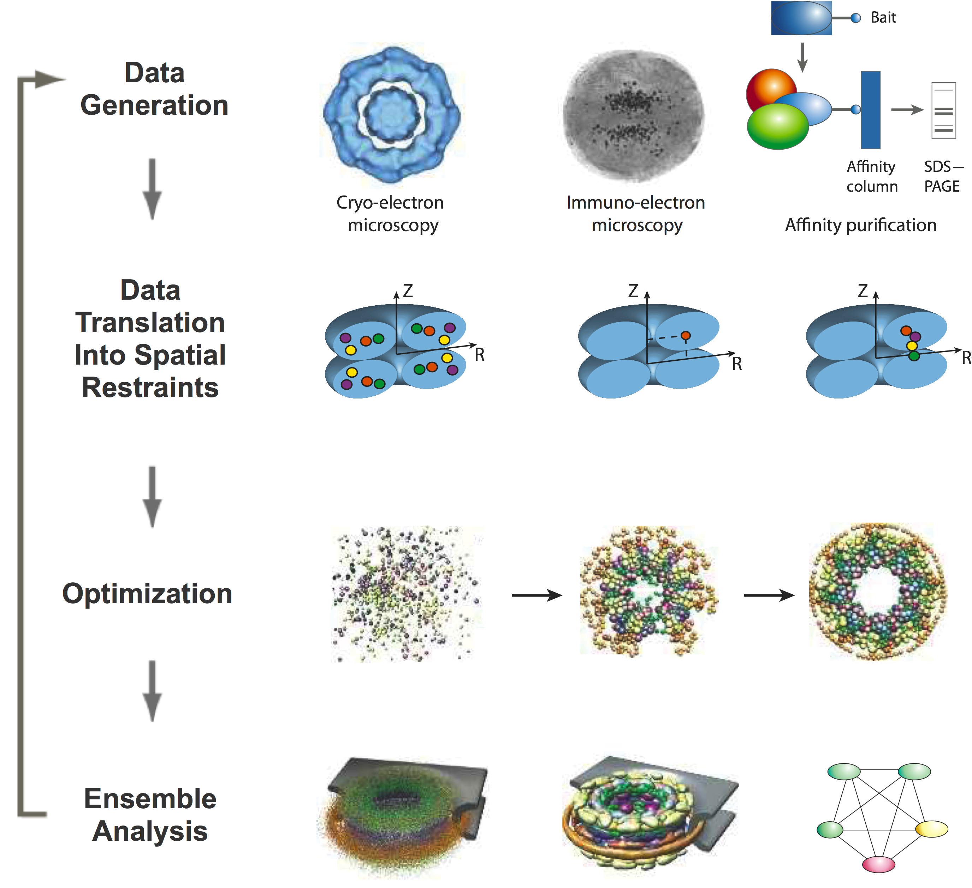Fig. 3. Integrative structure determination by satisfaction of spatial restraints. The four steps to determine a structure by integrating varied data are illustrated using the NPC as an example. These steps are data generation, data translation into spatial restraints, optimization, and ensemble analysis. First, structural data are generated by experiments, such as cryo-EM (left), immuno-EM (centre) and affinity purification of subcomplexes (right). Many other types of information can also be included. Second, the data and theoretical considerations are expressed as spatial restraints that ensure the observed symmetry and shape of the assembly (from cryo-EM, left), the positions of constituent gold-labeled proteins (from immuno-EM, centre) and the proximities of the constituent proteins (from affinity purification, right). The assembly is indicated in blue, and constituent proteins are indicated as colored circles. Third, an ensemble of structural solutions that satisfy the data is obtained by minimizing the violations of the spatial restraints (from left to right). Fourth, the ensemble is clustered into sets of distinct solutions (left), and analyzed in different representations, such as protein positions (centre) and protein–protein contacts (right). The integrative approach to structure determination has several advantages. First, synergy among the input data minimizes the drawbacks of incomplete, inaccurate and/or imprecise data sets. Each individual restraint contains little structural information, but by concurrently satisfying all restraints derived from independent experiments, the degeneracy of structural solutions can be markedly reduced. Second, this approach has the potential to produce all structures that are consistent with the data, not just one structure. Third, the variation between the structures that are consistent with the data allows an assessment of whether there are sufficient data and how precise the representative structure is. Last, this approach can make the process of structure determination more efficient, by indicating which measurements would be the most informative.

As for static structures, we suggest that to overcome the limitations of single methods, we need to develop an approach that is capable of integrating data from a variety of experimental and theoretical sources. We expect that a wide range of other fields dealing with modeling complex systems will contribute key ideas to modeling structural dynamics of macromolecular complexes. Examples include animation for movies, where physically realistic dynamics modeling techniques are coupled with high level control to ensure that the overall system has the needed properties^{43,44}; kinematics in robotics, where motions can be designed for achieving a set of pre-defined goals^{44,45}; the master equation in chemical kinetics that captures rates of transitions between different states⁴⁶; physically realistic molecular dynamics simulations, where every attempt is made to make the trajectories correspond to reality⁴⁷⁻⁵⁴; and simplified physical simulations, such as Brownian dynamics⁵⁵ and modeling of transitions⁵⁶. However, none of these approaches is generally accurate, applicable on all time and size scales of interest, capable of describing all properties of interest, and able to include all available experimental data and theoretical considerations. Compared to describing static structures of assemblies, methods for describing structural dynamics are in their nascent stage.

B.4 Impact of integrative methods

Our objective is the development of a computational approach that makes the most out of varied experimental data and theoretical considerations. Such a hybrid approach will be more efficient, produce more accurate structures at a higher resolution, and be more likely to succeed than any individual method. Integrative methods will allow interpretation of experimental, physical, and statistical data in the most productive way and will guide new experiments in promising directions. They will also allow us to explore the space of solutions more thoroughly, avoiding reliance on a single model in under-determined situations.
To demonstrate the direct impact of our methods on biology and to obtain feedback for their further development, we will continue to be proactively engaged in collaborations with experimentalists, both within and outside of the NCDIR (eg, Core 2, Projects 6-10). We also attach Letters of Collaboration and Support to emphasize this point (Program Introduction).
We have already used preliminary versions of our hybrid approach to contribute to the structure determinations of the first eukaryotic ribosome from S. cerevisiae^{36,37}, the E. coli ribosome¹⁶, the first mammalian ribosome from C. lupus³³, the baker’s yeast nuclear pore complex^{6,24} (Section C.2), the actin/scruin complex³⁵, the TriC chaperonin³⁷, human Hsp90⁵⁷, 20S proteasome (in collaboration with Yifan Cheng), Ryr1 voltage gated channel⁵⁸, 26S proteasome (in collaboration with Wolfgang Baumeister), and antigen – antibody complexes (in collaboration with Pfizer Inc.). In all of these cases, our integrated platform improved efficiency, accuracy, resolution, and completeness of the structural coverage of the studied assembly.

B.5 Summary
A comprehensive structural description of proteins, nucleic acids, and their assemblies will help us discover the principles that underlie cellular processes and bridge the gaps between genome sequencing, functional genomics, proteomics, and systems biology. Our broad objective is to contribute to this effort by developing methods for sampling structures and trajectories of macromolecular assemblies that are consistent with all available information from experimental methods, physical theories, and statistical preferences extracted from biological databases. Such an integrated system will help to maximize efficiency, accuracy, resolution, and completeness of the structural coverage of macromolecular assemblies.

C. PROGRESS REPORT
In the three years of the current grant period, starting on 08/01/05, we published 21 papers and submitted additional 4 manuscripts that cover the Specific Aims of the grant, involving the development and application of methods for integration of data into spatial models of subcellular processes. While we were productive with the modeling of static structures, the development of approaches to modeling dynamic processes based on varied data (a very difficult problem) was slower and is addressed in Specific Aim 3 in Section D. First, we outline the theory of our integrative approach to characterizing macromolecular assembly structures (Section C.1). Second, we describe the software engineering of the Integrative Modeling Platform (IMP) package (Section C.2), now funded by a separate NIH/NIGMS grant (R01 GM083960; A. Sali, PI). Third, we highlight an example, the structure determination of the nuclear pore complex (Section C.3). Fourth, we outline several integrative methods and sample applications that include protein structure modeling at atomic resolution (Section C.4). Finally, we describe extraction of spatial restraints from bioinformatics analyses of protein sequences and structures (Section C.5).

C.1 Modeling the static structures of macromolecular assemblies by satisfaction of spatial restraints
We review here the underlying theory and methods of our integrative determination of static structures^{2,3,6,24}.

Formalization of the problem. As introduced above, structural characterization is expressed as an optimization problem (Fig. 3). In this view, 3D models that are consistent with the input information are calculated by optimizing a scoring function. The three components of this approach are (i) a representation of the modeled assembly, (ii) a scoring function consisting of the individual spatial restraints, and (iii) optimization of the scoring function to obtain all possible models that satisfy the input restraints.
Representation. In the optimization, the modeled structure is represented by a hierarchy of particles, defined by their positions and other properties (Fig. 4a). For a protein assembly, the hierarchy can include atoms, atomic groups, amino acid residues, secondary structure segments, domains, proteins, sub-complexes, symmetry units, and the whole assembly. The coordinates and properties of particles at any level are calculated from those at the highest resolution level. Different parts of the assembly can be represented at different resolutions to reflect the input information about the structure. Moreover, different representations can also apply to the same part of the system. For example, immunoprecipitation may indicate proximity between two proteins and cross-linking may indicate which specific residues are involved in the interaction.
Scoring function. The most important aspect of structure characterization is to accurately capture all experimental, physical, and statistical information about the modeled structure (Figs. 2-4) (Core 1, Project 2). To do so, the scoring function is defined as a sum of individual spatial restraints, ideally corresponding to probability density functions for the restrained features. These features include contacts, proximity, distances, angles, chirality, surface, volume, excluded volume, shape, symmetry, and localization of particles and sets of particles. For instance, the shape, density and symmetry of a complex or its subunits may be derived from x-ray crystallography⁶⁴ and EM⁵⁹; upper distance bounds on residues from different proteins may be obtained from NMR spectroscopy⁶⁰ and chemical cross-linking⁶¹; protein-protein interactions may be discovered by native mass spectrometry⁶², the yeast two-hybrid system⁶³, and calorimetry⁶⁴; two proteins can be assigned to be in proximity if they are part of an isolated sub-complex identified by immunoprecipitation⁶⁵ (Core 1, Project 2). Increasingly, important restraints will be derived from pairwise molecular docking⁶⁶, statistical preferences observed in the structurally defined protein-protein interactions⁶⁷, and analysis of multiple sequence alignments⁶⁸.
An interpretation of the data in terms of a spatial restraint generally involves identifying the restrained components (ie, structural interpretation) and the possible values of the restrained feature implied by the data (Fig. 4). If structural interpretation of the data is ambiguous (ie, the data cannot be uniquely assigned to specific components), only “ambiguous restraints” (or “conditional restraints”) can be applied. For example, an immunoprecipitation experiment indicates which protein types but not which instances interact with each other, resulting in an ambiguity when there is more than one copy of a protein per assembly. An ambiguous restraint considers all alternative structural interpretations of the data, each one of which corresponds to a set of one or more independent “optional restraints”. The selection of the best alternative interpretation is achieved as part of the optimization process. At each optimization step, only the most likely interpretation is chosen. Formally, the selection of the best data interpretation is achieved through the activation of optional restraints by operator functions that evaluate all optional restraints based on the current assembly structure and return the subset of restraints that lead to the smallest total restraint violation.
Optimization methods. It is crucial to have access to multiple optimization methods as different methods work better with different choices of representation and different restraints. We are currently using optimization methods implemented in IMP⁶⁹ and MODELLER¹⁷, including simple conjugate gradient⁷⁰ and molecular dynamics optimizers⁶ as well as more sophisticated schemes, such as self-guided Langevin dynamics^{71,72} and the replica exchange method⁷³; all of these methods can refine positions of the individual particles as well as treat subsets of particles as rigid bodies.
Outcomes. There are three possible outcomes of the calculation. First, if all models that satisfy the input information are similar, there is probably sufficient data for prediction of the unique native state. Second, if different models are consistent with the input information, the data are insufficient to define the single native state or there are multiple native structures. The structural differences between the models may suggest additional experiments to narrow down the possible solutions. Third, if no models satisfy all input information, the data or their interpretation in terms of the restraints are incorrect.
Estimating accuracy. Estimating the accuracy of a model is important and difficult. Since the real structure is not known, it is impossible to know with certainty the accuracy of the proposed model. Therefore, it is impossible to know with certainty the accuracy of the proposed structure. Nevertheless, our confidence can be increased based on five considerations: (i) self-consistency of the experimental data; (ii) structural similarity among the configurations in the ensemble that satisfy the input restraints; (iii) simulations where a native structure is assumed, corresponding restraints simulated from it, and the resulting calculated structure compared with the assumed native structure; (iv) confirmatory spatial data that were not used in the calculation of the structure (eg, criterion similar to the crystallographic free R-factor⁷⁴ can be used to assess both the model accuracy and the harmony among the input restraints); and (v) patterns emerging from a mapping of independent and unused data onto the structure that are unlikely to occur by chance.

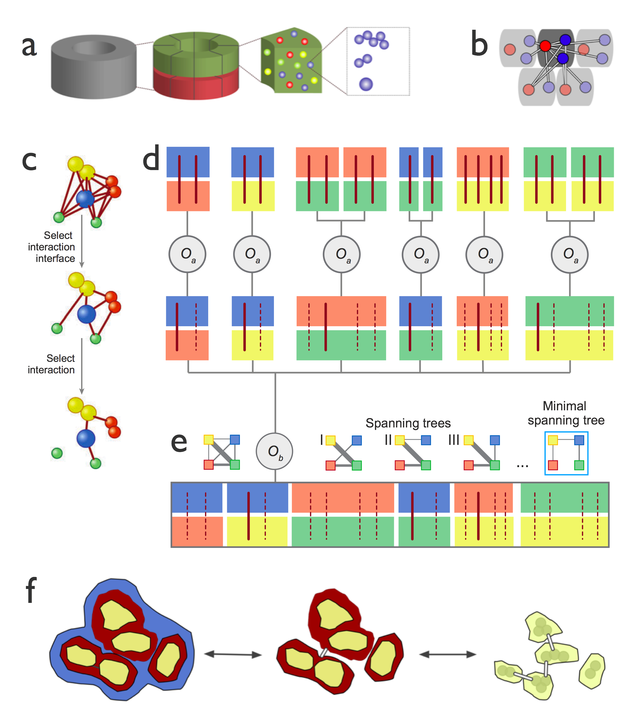
Fig. 4. (a) Hierarchy of representation. The NPC provides an example of a hierarchically organized assembly, where the assembly (gray) consists of two rings (green and red), each one of which consists of 8 units called “half spokes”. Each half spoke in turn consists of 30 proteins (red and yellow spheres), each one of which consists of one or more domains. In fact, each protein may be described simultaneously by several structural representations, each consisting of a set of particles defined by their type and instance identifier. (b) Ambiguity in structural interpretation of the data. When there are multiple copies of a the same protein type in the assembly, it is ambiguous which copies are involved in a given interaction. This ambiguity is illustrated for the NPC, where an interaction (line) between “blue” and “red” proteins can occur within one half-spoke or between neighboring half spokes, indicated by gray boxes. (c-e) Ambiguous (conditional) restraints. We use a conditional restraint on protein contacts derived from a single affinity purification experiment that identified 4 protein types (yellow, blue, red, green) as an example. It was obtained from an assembly containing a single copy of the yellow, blue, and red protein and two copies of the green protein. (c) A single protein is represented by either one bead (blue and green proteins) or two beads (yellow and red proteins); alternative interactions between proteins are indicated by different edges. (d) Protein contacts are selected in a decision tree-like evaluation. Red vertical lines indicate restraints that encode a protein contact; thick vertical lines are a subset of restraints that are selected for contribution to the final value of the conditional restraint, whereas dotted vertical lines indicate restraints that are not selected. (e) The composite graph is a connected graph that consists of nodes for all identified protein types (square nodes) and edges for all pairwise interactions between protein types (left of the O_{b} operator); edge weights correspond to violations of interaction restraints and quantify how consistent the corresponding interaction is with the current assembly structure. A spanning tree is a graph with the smallest possible number of edges that connect all nodes; a subset of 4 out of 16 spanning trees is indicated to the right of the O_{b} operator. The minimal spanning tree is the spanning tree with the minimal sum of edge weights (ie, restraints score). The sample affinity purification implies that at least three of the following six possible types of interactions must occur: blue-red, blue-yellow, blue-green, red-green, red-yellow, and yellow-green. In addition, (i) the three selected interactions must form a spanning tree of the composite graph; (ii) each type of interaction can involve either copy of the green protein; and (iii) each protein can interact through any of its beads. These considerations can be encoded through a tree-like evaluation of the conditional restraint. At the top level, all possible bead-bead interactions between all protein copies are clustered by protein types. Each alternative bead interaction can be restrained by a restraint corresponding to a harmonic upper bound on the distance between the beads; these are termed “optional restraints” because only a subset is selected for contribution to the final value of the conditional restraint. Next, an operator function (O_{a}) selects only the least violated optional restraint from each interaction type, resulting in six restraints (thick red lines) at the middle level of the tree. Finally, a minimal spanning tree operator (O_{b}) finds the minimal spanning tree corresponding to the combination of three restraints that are most consistent with the affinity purification (thick red lines). The whole restraint evaluation process is executed at each optimization step on the basis of the current configuration, thus resulting in possibly different subsets of selected optional restraints at each step. (f) Hierarchy of restraints. Spatial restraints can be imposed on components at any level of the structural hierarchy.

- C.2 Software engineering of IMP
We have already designed and implemented much of the core functionality of IMP. Conceptually, this kernel code is centered on a Model, which is a collection of Particles and associated Restraints. Each Particle has a number of user-specified attributes, such as x, y, and z coordinates. Each Restraint computes a score using the attributes of some subset of the Particles, such as penalizing a pair of Particles for being too far apart. Optimizers then search for values of the attributes that minimize the sum of the scores of the Restraints. Such a modular framework easily incorporates a wide variety of system representations, restraints, and optimization schemes. The library can be used from either C++ or Python.
The IMP framework is designed to address a variety of modeling problems. Some examples include (i) developing methods for integrated fitting into cryo-EM maps and protein structure modeling^{5,38,75,76}, (ii) determining the structure of the 26S proteasome (Core 2, Project 9), (iii) determining a higher resolution structure of the NPC (Section D.2), as well as (iv) modeling transport through the NPC (Section D.3). Despite the relative immaturity of the IMP code, several other research groups are already using IMP or contributing code for new restraints to it (eg, Marc Marti-Renom is contributing comparative modeling of RNA systems; Joerg Gsponer is contributing various NMR data-derived restraints; and Baldo Oliva is contributing distance restraints inferred from analysis of sequence profiles of interacting proteins).
IMP software design was initiated by a short NCDIR supplement grant in year 2 of NCDIR. In parallel, Douglas Sheeley (the NCDIR Program Officer) encouraged us to seek independent long-term funding. Therefore, we secured a new NIH/NIGMS R01 grant (GM083960; A. Sali, PI) whose Specific Aims include professional software engineering, implementation, testing, bug tracking, version control, documentation, distribution, feature request handling, and user support for IMP. Because these activities are subject of another grant, they are not described in the current proposal. Nevertheless, they are key elements of our overall effort on maximizing the impact of integrative structure determination.

C.3 Structural characterization of the nuclear pore complex
Using the approach outlined above, we determined the native configuration of the 456 proteins (nups) in the yeast NPC, collaborating with NCDIR investigators Michael Rout and Brian Chait at the Rockefeller University^{6,24,77,78} since 2001. This seven-year project thus proved that we can collaborate very interactively and intensely, despite a significant geographic separation. The collaboration was made possible by several personal visits of the PI’s and students in San Francisco and New York per year, videoconference calls using standard Skype software on our personal computers as well as specialized Tandberg equipment every few weeks, yearly multi-day retreats, telephone conversations, and daily email exchanges. These modes of interaction will continue in the next grant period.
NPCs are large (~50 MDa) proteinaceous assemblies spanning the nuclear envelope (NE), where they function as the sole mediators of bidirectional exchange between the nucleoplasmic and cytoplasmic compartments in all eukaryotes⁷⁹. EM images of the yeast NPC at ~200 Å resolution revealed that the nuclear pore forms a channel by stacking two similar rings, each one consisting of 8 copies of a “half spoke”⁸⁰. Each half spoke contains 30 different proteins of unknown structure, resulting in a total of 456 proteins in the whole nuclear pore.
Although low-resolution EM has provided valuable insights into the overall shape of the NPC, the spatial configuration of its component proteins was unknown. A detailed description of the NPC’s structure was needed to understand its function and assembly, and to provide clues to its evolutionary origins. Due to its size and flexibility, detailed structural characterization of the complete NPC assembly has proven to be extraordinarily challenging. Further compounding the problem, atomic structures have only been solved for domains covering ~5% of the protein sequences⁷⁸.
To determine the molecular architecture of the NPC, we collected a large and diverse set of biophysical and biochemical data, and translated it into spatial restraints on the NPC (Fig. 3). The relative positions and proximities of the NPC’s constituent proteins were then produced by satisfying these spatial restraints, using the approach described in Section C.1 and illustrated in Fig. 5. The optimization relies on conjugate gradients and molecular dynamics with simulated annealing. It starts with a random configuration of nups and then iteratively moves these nups so as to minimize violations of the restraints (Fig. 5a). To comprehensively sample all possible structural solutions that are consistent with the data, we obtained an “ensemble” of 1,000 independently calculated structures that satisfied the input restraints (Fig. 5b). After alignment of these structures, the ensemble was converted into the probability of finding a given nup at any point in space (ie, the localization probability). The resulting localization probabilities yielded single pronounced maxima for almost all nups, demonstrating that the input restraints define one predominant NPC architecture. The average standard deviation for the separation between nup centroids is 4.9 nm. Given that this level of precision is less than the diameter of many nups, our map is sufficient to determine the relative positions of nups in the NPC. Although each individual restraint may contain little structural information, the concurrent satisfaction of all restraints derived from independent experiments drastically reduces the degeneracy of the structural solutions (Fig. 5c).
Our structure (Fig. 6) reveals that half of the NPC is made of a core scaffold, which is structurally analogous to vesicle coating complexes (Proposal Introduction). This scaffold forms an interlaced network that coats the entire curved surface of the nuclear envelope within which the NPC is embedded. The selective barrier for transport is formed by a large number of proteins with disordered regions that line the inner face of the scaffold. The NPC consists of only a few structural modules. These modules resemble each other in terms of the configuration of their homologous constituents, thus providing clues to the ancient evolutionary origins of the NPC.

C.4 Augmenting experimental structure determination with atomic protein structure modeling
Over the last decade, we have been involved in a number of projects that have led to the structural descriptions of proteins and their assemblies through combining comparative modeling and experimental methods, including x-ray crystallography, NMR spectroscopy, cryo-EM, cryo-electron tomography, and SAXS. Although these applications were smaller in scale and involved systems at higher resolutions than the NPC study mentioned above, they inspired us to develop the theoretical framework for integrating varied types of structural information (Section C.1). In addition, they prepared us for merging both high- and low-resolution information for obtaining pseudo-atomic models of large assemblies, as proposed here for the NPC (Section D.2) and several other systems (Core 2).
We contributed to the structure determination of PEBP2/CBF Runt-domain by combining the sparse restraints determined by NMR spectroscopy and the alignment to several remotely related immunoglobulin structures⁸¹.
We facilitated crystallographic structure determination of a number of proteins by providing comparative models
- for molecular replacement calculations⁸².
We helped construct pseudo-atomic models of the first eukaryotic ribosome from baker’s yeast^{36,37}, the E. coli ribosome¹⁶, and the first mammalian ribosome from C. lupus⁸³ by providing comparative models for fitting into cryo-EM maps at resolutions from 8-15 Å.
- We refined the structures of scruin domains linking the actin filaments, in the context of ~10Å resolution cryo-EM density maps of the Limulus acrosomal bundle^{84,85}.
- We developed a protocol for determining the configurations of multi-domain proteins and protein complexes by a combination of molecular docking and fitting to the SAXS profile⁸⁶. We also applied this approach to mapping different functional states of human Hsp90 in solution⁵⁷.
- We are helping to position PSD-95 and CAM-K in the postsynaptic density area of a synapse by providing comparative models for use as templates in the analysis of the cryo-electron tomography density maps at ~60 Å resolution (with Wolfgang Baumeister and Mary Kennedy).
- Additional assemblies determined with our hybrid approach to comparative modeling and cryo-EM include 20S proteasome (with Yifan Cheng), RyR1 voltage gated channel⁵⁸, the TriC chaperonin⁸⁷, 26S proteasome (with Wolfgang Baumeister), and antigen – antibody complexes (with Pfizer Inc.).
- To support cryo-EM structure determination in general, we have developed automated protocols for simultaneous protein structure refinement and fitting into cryo-EM density maps at 5-15 Å resolution^{5,38,75,88}. These procedures significantly improve the positions and orientations of the subunits in the density map. In parallel, they also improve the accuracy of the conformations of the subunits by reducing errors in the sequence-structure alignment, conformations and positions of loops, as well as the packing of secondary structure segments.
- C.5 Spatial restraints on macromolecular assemblies derived from analysis of protein sequences and structures
- Structure characterization of assemblies depends on the availability of spatial restraints on the subunit configuration. Such restraints can be derived from an analysis of existing protein sequence, structure, and interaction databases. Several such projects include:
- Database of structurally defined protein interfaces. We developed PIBASE⁸⁹, a comprehensive relational database of structurally defined interfaces between pairs of protein domains extracted from structures in the Protein Data Bank (PDB) and the Probable Quaternary Structure (PQS) server⁹⁰, using domain assignments from the Structural Classification of Proteins (SCOP) and CATH fold classification systems. This resource proved invaluable for several subsequent studies.
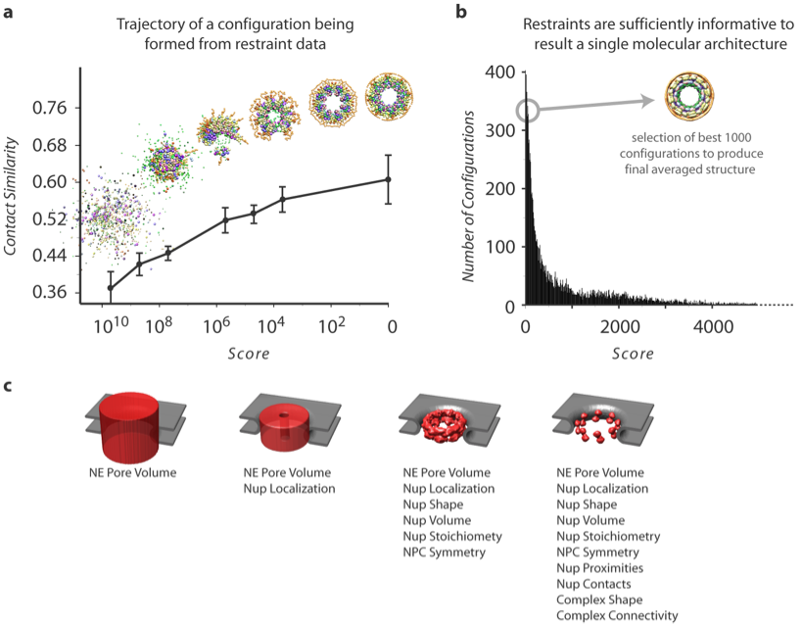
Fig. 5. Determination of the structure of the NPC by satisfaction of spatial restraints. (a) Representation of the optimization process as it progresses from an initial random configuration to an optimal solution. The graph shows the relationship between the score (a measure of the consistency between the configuration and the input data) and the average contact similarity. The contact similarity is a measure of how similar two configurations are in terms of the number and types of their protein contacts; two proteins are considered to be in contact when they are sufficiently close to one another given their size and shape. The average contact similarity at a given score is determined from the contact similarities between the lowest scoring configuration and a sample of 100 configurations with the given score. Error bars indicate standard deviation. Representative configurations at various stages of the optimization process from left (very large scores) to right (with a score of 0) are shown above the graph; a score of 0 indicates that all input restraints have been satisfied. As the score approaches zero the contact similarity increases, showing that there is only a single cluster of closely related configurations that satisfy the input data. (b) Distribution of configuration scores demonstrates that our sampling procedure finds configurations consistent with the input data. Also shown is the localization volume representation of the NPC derived from the 1000 best scoring configurations. These configurations satisfy all the input restraints within the experimental error. (c) The position of each nup is increasingly constrained by the addition of different types of synergistic experimental information. As an example, here each panel illustrates the localization of 16 copies of Nup192 in the ensemble of NPC structures generated, using the datasets indicated below. The 3D localization probability is contoured at 80% of its maximal value (red). The smaller the volume, the better localized is the nup. The NPC structure is therefore essentially “molded” into shape by the large amount of experimental data.

Predicting interacting proteins by homology. We first developed a statistical potential for residue contacts, derived from binary domain interfaces in PIBASE⁹¹. Next, models of putative complexes were generated by comparative modeling using complexes of known structure as templates. Finally, the interacting proteins were predicted by assessing the models with the aid of the statistical potential.
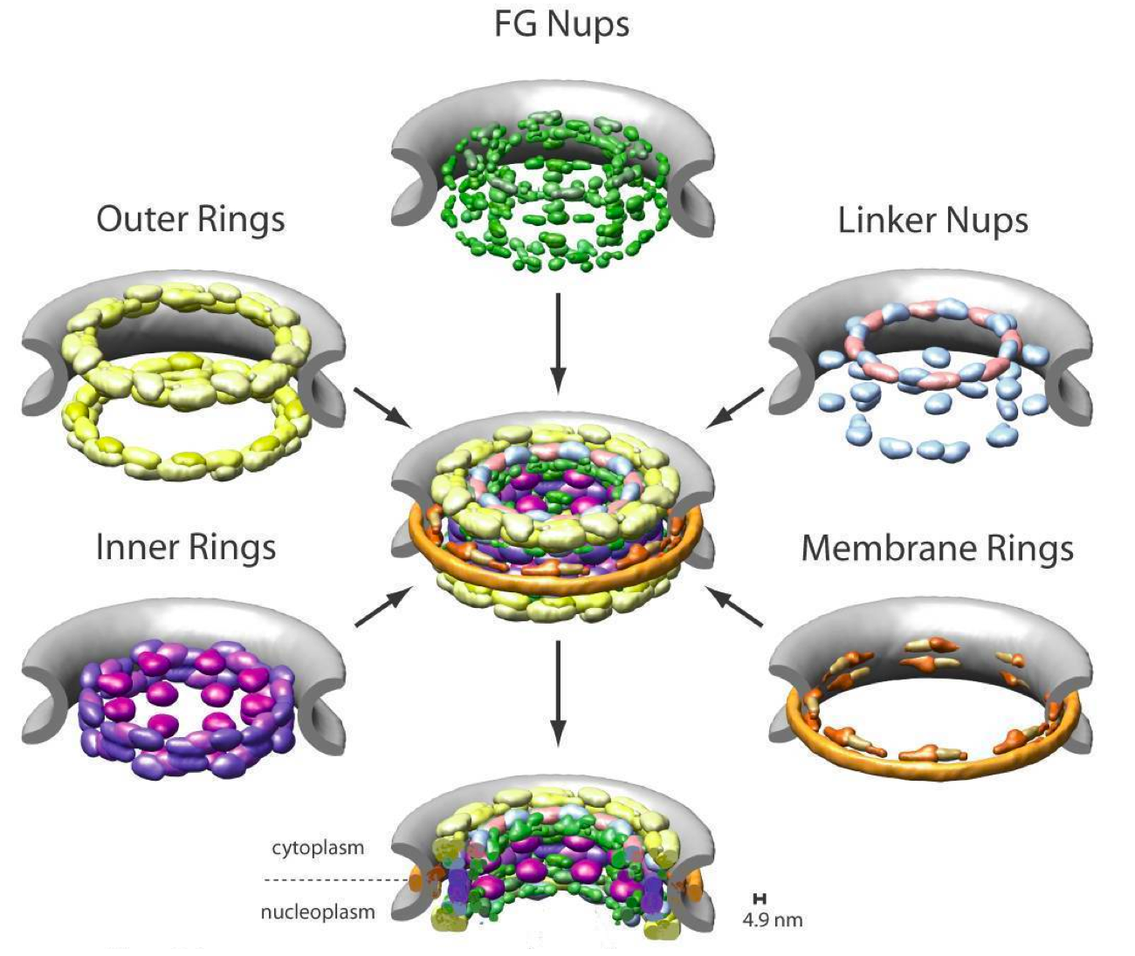
Fig. 6. Localization of major substructures and their component nups in the NPC. The nups are represented by their localization volumes and have been colored according to their classification into five distinct substructures based on their location and functional properties: the outer rings in yellow, the inner rings in purple, the membrane rings in brown, the linker nups in blue and pink, and the FG nups (for which only the structured domains are shown) in green. The pore membrane is shown in gray.

Comparative patch analysis. This analysis aims to provide useful spatial restraints for the structural characterization of binary and higher order protein complexes^{92,93}. It relies on structurally defined interactions of each of the complex components or their homologs with any other subunit. For each component and its homologs, we gather all known binding modes. These modes are then used to restrain conventional molecular docking, resulting in a set of binary domain complexes that are subsequently ranked by geometric complementarity and the statistical potential extracted from PIBASE.
Theoretical analysis for docking of multiple subunits. Using a graph theoretic analysis of multiple docking, we characterize analytically the relationship between the accuracies of the multiple docking and the binary docking it uses⁹⁴. This analysis also allows us to quantify the amount of additional information required for characterization of large assemblies at a given level of accuracy.
Configuration of similar subunits in an assembly. Based on a template configuration for an assembly, we enumerate all positions that each similar subunit can occupy in a given quaternary configuration⁹⁵. For each enumerated configuration, a model of the assembly is built and scored using a weighted combination of three statistical potentials and an energy function. The positions of the subunits are then predicted based on their relative frequencies in the top ranked assembly configurations.
Binary docking of proteins using ambiguous NMR-derived restraints. We developed a computational method for determining heterodimeric configurations, given the amino acid residue content of the binding sites measured by NMR spectroscopy⁹⁶ and the known or modeled subunit structures⁹⁴. First, we identify the interacting binding sites based on the labeled amino acid residue types by exhaustively sampling each subunit surface. Second, we dock the subunits, restraining the identified binding sites to form an interface. Third, we score each of the resulting configurations by geometric complementarity as well as the difference between the modeled and experimental residue content. Lastly, we obtain the final configuration by a clustering analysis. A benchmark demonstrates that (i) a binding site may be successfully identified with as few as 3 labeled residue types, (ii) certain combinations of residue types yield a more accurate and precise configuration of the complex than others, and (iii) the final configuration is generally within 3 Å RMSD from the native complex. Therefore, the residue content of binding sites can provide sufficient information to determine an accurate configuration of a heterodimeric complex.

D. RESEARCH DESIGN AND METHODS
The first major goal is to improve our integrative approach for characterizing macromolecular assemblies based on varied types of data (Section C.1)¹⁻⁶. To achieve this objective, we will continue developing methods implemented in the IMP library for enumerating structures of macromolecular assemblies that are consistent with spatial restraints implied by various data (Sections C.2). In particular, we need to develop and benchmark methods for using restraints derived from chemical cross-linking, molecular docking, and affinity purification with domain deletion constructs (Specific Aim 1, Section D.1; Core 1, Project 2). We also need to develop sampling methods to satisfy these restraints when imposed on large and complex macromolecular systems (Specific Aim 2, Section D.2).
Our second major goal is to formulate a framework for a spatial description of dynamic processes involving macromolecules, as opposed to their static structures, also by satisfying what is known from experiment and from theory about the rates and ordering of key events (Specific Aim 3, Section D.3; Core 1, Project 3).
All of these developments are motivated by specific needs of our collaborators who are generating novel experimental data on several key biological systems and processes. Jointly, we will determine the pseudo-atomic structure of the NPC (as part of Specific Aim 1); the pseudo-atomic structure of 26S proteasome (Core 2, Project 9); the molecular architecture of yeast Spindle Pole Body (Core 2, Project 7); the architecture of the interleukin-2 enhanceosome complex (Core 2, Project 6); and a spatio-temporal model of macromolecular transport through the NPC (Specific Aim 3). Our long-term goals include modeling the development of the peroxisome (Core 2, Project 11), chromatin dynamics (Core 2, Projects 5 & 6), and the assembly of RNPs (Core 2, Project 8). These applications will demonstrate the utility of our computational approaches, provide feedback for their continued development, and contribute to specific areas of biology in which these assemblies play important roles.

D.1 Specific Aim 1: Develop spatial restraints on the structure of a given assembly that encode experimental data, physical theories, and statistical inferences
We need to enrich the current library of spatial restraint types to support the modeling of biological systems of interest to us. We will develop the following three types of restraints: First, an atom-atom distance restraint implied by chemical cross-linking, explicitly representing the cross-linker and the restrained subunits at atomic resolution. Second, a restraint on the relative orientation of two protein structures⁹⁴ based on an ensemble of solutions calculated by molecular docking. Third, a restraint on the relative orientation of two protein structures, based on affinity purification data from domain deletion constructs.
It is fatal to impose restraints that are more specific than justified by the data when solving structures by satisfaction of spatial restraints; it is merely sub-optimal to impose restraints that are looser than justified by the data. Therefore, we will aim to avoid over-interpreting the data from which restraints are derived. We will also take into account limited precision and accuracy of the conformations of the subunits that are restrained relative to each other.
Our development of methods for converting data into spatial restraints will rely heavily on benchmarking³. Since our methods will continue to be automated, we will be able to afford benchmarks with a sufficient number of systems of known structure to be informative. A general protocol for testing restraints in terms of their impact on structure calculation is as follows³: First, restraints will be simulated from the known structures, varying their number, precision, and accuracy. Second, the ensemble of structural solutions consistent with the tested restraints will be calculated with IMP. Third, the ensemble will be assessed in terms of precision and accuracy. Where possible, we will also rely on the actual experimental data as opposed to data simulated from known structures. This benchmarking will allow us to optimize various assumptions and parameters that invariably influence the conversion of data into spatial restraints.

D.1.1 Cross-linking restraints
Mass spectrometry can determine the identity of chemically cross-linked proteins in complexes as well as the identity of chemically cross-linked amino acid residues in proteins and complexes, thus providing low-resolution distance restraints on the cross-linked particles⁹⁷⁻¹⁰⁰. Although cross-linking data are of lower resolution and sparser than x-ray crystallography or NMR spectroscopy datasets, they can be obtained rapidly, in solution, and essentially without size limitations on the cross-linked proteins. Recent key advances in mass spectrometry renewed interest in this approach^{100,101}.
The NCDIR has already pioneered analytical cross-linking methodologies¹⁰² and will continue to refine them (Core 1, Project 2). Here, we aim to add functionality to IMP to convert knowledge of flexible chemical cross-linkers within and between proteins into a set of spatial restraints. Jointly with other restraints, the cross-linking restraints will help determine the relative orientations of the interacting subunits, and potentially also subunit conformations (although the latter application is not a significant aim of NCDIR). The types of spatial restraints that can be gleaned from cross-linking studies are as follows.
Solvent accessibility restraints. Probable solvent accessibility of an amino acid residue is revealed even when a cross-linker (or a mono-functional probe) attaches to only one residue. We can incorporate this information by explicitly modeling the attached cross-linker in its atomic detail (below), thus avoiding the overlaps between the cross-linker and protein atoms. Alternatively and more simply, we can require that the cross-linker attachment site be exposed to the solvent by imposing a restraint on the atomic solvent accessibility, as already implemented in MODELLER. In either case, models of complexes in which the labeled amino acid residue is buried by a protein-protein interaction will produce unfavorable scores and thus be avoided in the optimized ensemble of good-scoring solutions.
Distance restraints on specified residues. In IMP, proteins are represented one or more particles (eg, atoms, residues, or domains). For generality, there should be no requirement that the two cross-linked species be represented by the same resolution particles; for example, we should be able to use a cross-linking restraint on a protein of known atomic structure and a protein represented by a sphere. The cross-linker implies an upper (and potentially lower) bound on the distance between the two cross-linked particles identified by the experiment; the upper (lower) bound is the sum of the maximal (minimal) linker length and the two particle radii, potentially multiplied by a tolerance factor larger (smaller) than 1 to account for distortions and other uncertainties.
Distance restraints on unspecified residues. In this case, the experiment does not identify the cross-linked atoms or residues, only the cross-linked domains or proteins. Therefore, there are in general many possibilities for the restrained particles and a simple form of the conditional restraint must be used (Fig. 4): the assignment of the cross-linked particles themselves becomes part of the optimization. In each step of the optimization, the restraint is assigned to the pair of particles that is most consistent with it, before evaluating the “forces” resulting from the restraints. Thus, the optimization results not only in the optimal structural solution, but also in the assignment of the restraint to a specific set of particles. This ambiguity of course disappears when a single particle is used to represent the protein (ie, the protein is a sphere). Another potential level of ambiguity occurs (here as well as for the distance restraints on specified residues) when multiple copies of the same cross-linked protein type occur in the modeled system, as was the case for the highly symmetric nuclear pore complex. In this case, too, a conditional restraint can easily handle the initial uncertainty about the instance of the cross-linked protein. It is of course preferable to use the non-ambiguous restraints for which the restrained particles are known at the outset (above), compared to the ambiguous restraints described here.
Explicit atomic modeling of the cross-linker. It is also possible to replace the upper and lower distance bounds described above with explicit atomic modeling of either intra- or inter-molecular cross-linkers. We will generate restraints corresponding to the cross-linker bond lengths, bond angles, dihedral angles, and non-bonded interactions with the aid of the CHARMM-22 force field¹⁰³, just as we already do for the modeling of non-standard residues in the context of comparative modeling with MODELLER. The proposed atomic modeling of a cross-linker would go beyond most of the previous attempts to make use of chemical cross-linkers in protein structure optimizations, which represented the cross-linkers as simple distance restraints or constraints on the pair of cross-linked protein atoms¹⁰⁴. Explicit atomic modeling of the cross-linker may overcome the potential problem of an implied overlap between the cross-linker and the protein in the case of simple distance bounds on residues separated by a convex protein surface. While modeling a cross-linker that is unambiguously assigned to a given pair of particles (eg, atoms, residues, domains, or proteins) is straightforward, the ambiguous particle assignment can also be treated, at least in principle; however, we don’t expect there will be a practical need for explicit atomic modeling in the ambiguous assignment cases.
Benchmarking. We will assess the performance of our cross-linking restraints by determining how many cross-linking restraints are needed to reproduce correctly molecular architectures of complexes with a varying number of subunits.

D.1.2 Translation of potential binding mode(s) for a pair of interacting proteins into spatial restraints
In our previous work on the NPC, we relied heavily on extensive low-resolution data to solve for the relative positions, but not orientations, of proteins in the complex. In the absence of high-resolution experimental data describing the relative orientations of proteins in a complex, information about relative binding orientation of two proteins may be obtained from molecular docking¹⁰⁵ or comparative protein structure modeling⁹¹. Next, we describe how we will use these two sources of information to formulate spatial restraints for subsequent integrative computations with IMP.
Pairwise molecular docking. The docking techniques typically sample and score a set of protein configurations and return a ranked list of varied docking solutions. To get these solutions, we rely on PATCHDOCK¹⁰⁶, but other docking programs and web servers could also be used¹⁰⁷⁻¹⁰⁹. For more accurate performance, docking may be restrained to binding sites identified by comparative patch analysis (Section C.4)^{4,93}. Next, each of the subunits is assigned four labeled reference points (Fig. 7). For each docking solution, we calculate all 16 distances between all inter-molecular pairs of reference points. A single multidimensional Gaussian (MDG) restraint is then defined, with a violation of , where and are the evaluated distances and inverse weights, respectively. We further combine these MDG restraints for each docking solution into a weighted exclusive-OR (XOR) restraint that first determines which of the docking solutions is most satisfied by the current configuration of the model, and then enforces the corresponding MDG restraint. This XOR restraint is a special case of the conditional restraint (Fig. 7) and has a violation of , where m is the tested configuration and w_{j} is the weight of the j-th docking solution (perhaps corresponding to the size of the cluster of docking solutions that it represents).
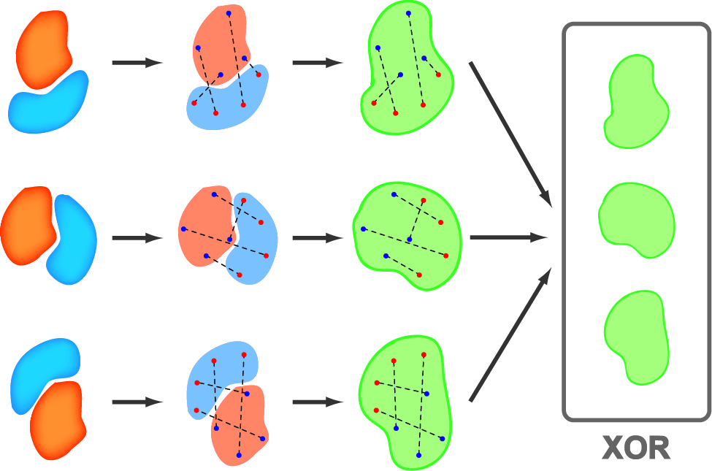

Fig. 7. Schematic of the three-subunit combination of restraints. First, the three relative orientations of two subunits (orange and blue) are assembled (far left). Second, the representative distance restraints are extracted. Third, the distance restraints are merged into a multidimensional Gaussian restraint representing the two relative orientations (green). Fourth, the three multidimensional Gaussian restraints are combined into an exclusive-OR restraint (grey box).

Comparative modeling. In addition to pairwise docking methods, we may also orient two proteins by inferring the binding mode from homology to a binary complex of known structure⁹³. Our current protocol takes as input the individual structures or models of two proteins known to interact with each other. PIBASE, our comprehensive database of structurally defined binary domain interfaces, is then queried to identify interfaces between domains that are similar to those of the target proteins. Depending on the query results, either a single or multiple possible interfaces and binding modes will be available for use as interface templates. Next, standard comparative modeling with MODELLER¹⁷ generates a model of the complex for each interface template. These models are then assessed by a statistical potential derived from the propensity of residue-residue interactions across interfaces of known structure⁹¹. Models that are judged to be sufficiently accurate can be used in the same way as docking solutions above to generate spatial restraints for IMP.

D.1.3 Restraints from affinity purification with domain deletion constructs
Previously, a large set of affinity purification experiments provided invaluable information about protein proximities and contributed to the localization of the constituent nups in the NPC (Section C.3). Only a slightly modified version of the existing protocol can in fact restrain protein orientations in addition to relative positions, when the atomic structures or models of the interacting multi-domain proteins are available (as is the case for most of the nups). Briefly, we conduct an exhaustive set of affinity purification experiments in which the domain closest to either the N-terminus or C-terminus of a protein is truncated. Proteins that elute in a full affinity purification experiment, but do not elute in the same experiment with a truncated region, are assumed to interact via the truncated region (Core 1, Project 2). A modified implementation of conditional restraints (Fig. 4) will be used to interpret such data (Fig. 8).
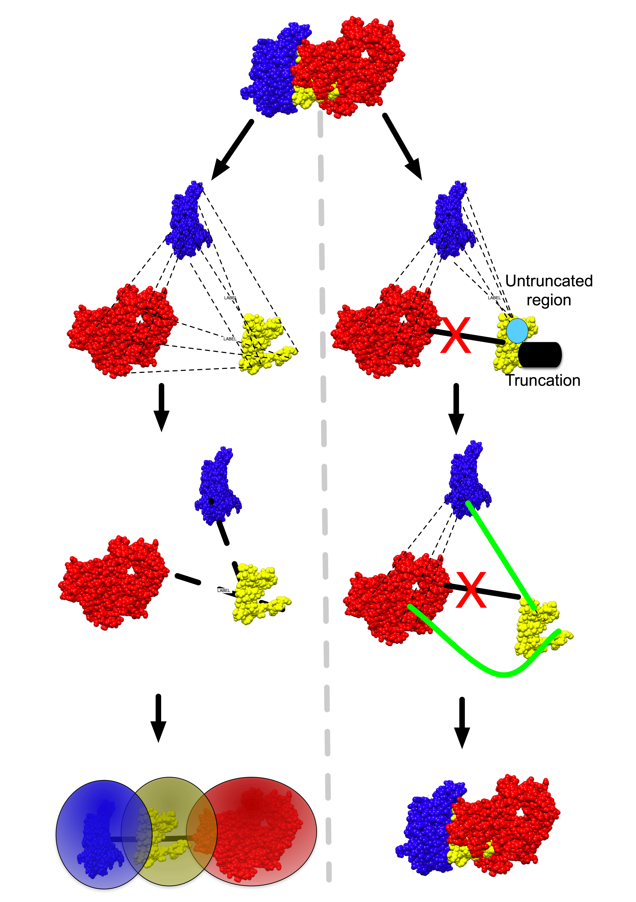
Fig. 8. Conditional restraints from domain-deletion affinity purification. (left) Previously, conditional restraints (Fig. 4) were employed to chose between many possible relative protein positions, given affinity purification data, but could not distinguish between different protein orientations. (right) Conditional restraints implied by affinity purifications with truncated proteins operate in essentially the same manner, but can provide domain-level resolution, illustrating a powerful synergy with information about protein structures. Possible domain connectivities are first enumerated and represented as a graph. Next, a minimal spanning tree is generated to select the optimal set of domain connectivities, thus orienting the proteins relative to each other.
The proteins will be represented with their rigid atomic structures or comparative models. The few long stretches of sequence that cannot be modeled by comparative modeling may be represented at lower resolution with a bead or beads of appropriate size. Affinity purification results will be encoded in a composite graph, a fully connected graph that consists of nodes for all identified protein domains and edges for all possible pairwise interactions between domains (Fig. 5). Interactions are represented as harmonic upper bound restraints on these distances, and edge weights quantify violations of these restraints.
Each affinity purification experiment without truncations provides a group of interacting proteins that can be represented as a composite graph. The composite graph is a fully connected graph consisting of nodes for each protein and edges for each possible protein-protein interaction. We must (i) select the most appropriate domain-domain restraints among many possibilities to generate the overall protein connectivity and (ii) select one possible configuration of the protein types in the complex most consistent with the restraints. First, for each possible domain-domain interaction, we generate a distance restraint based on sequence length and an assumption of globularity for each domain. We then use a rank-and-select operator to choose the least violated domain-domain restraint for each protein-protein interaction. It is apparent that the true set of protein-protein interactions must form a spanning tree of the resulting composite graph. Therefore, we select a minimal spanning tree of the composite graph as the protein configuration that minimally violates the given set of restraints.
Next, given a second composite containing a domain truncation, we can assume that, if any proteins are missing as compared to the original composite, interactions between the missing proteins and the truncated protein must have occurred through the truncated region. Thus, we restrict the set of possible domain-domain restraints to force at least one interaction between the truncated domain and missing proteins, and proceed with the minimal spanning tree procedure (Fig. 8). This way, we end up with a subset of restraints for protein connectivity that is directed to the correct domain. Taken together, restraints for many of these affinity purifications can solve for the domain-domain orientation of all subunits in a complex.
Assessment. Our interpretation of domain-deletion affinity purifications relies on the assumption that the domain truncations do not cause unfolding of the remaining domains in the protein. We are confident that few cases will violate this assumption when mapping modular proteins (such as nups^{77,78}) and when confining truncation points to regions that have already been identified as flexible linkers⁷⁸. Moreover, there can be a tremendous redundancy in the data for a given complex, as all proteins can have their truncation interactions mapped. However, even if some of our restraints are inaccurate, we can identify these restraints based on their inconsistency with the preponderance of the data. We will assess our structure and find such inconsistent restraints by jackknifing, as done for our current NPC structure^{6,24}. We will remove several random subsets of 10% of the restraints used in our optimization, rerun the optimization with the remaining data, and compare the results with and without the removed restraints. Given a multitude of restraints, we expect both a set of reasonable solutions and inconsistent restraints to clearly emerge from the data.
D.1.4 Determining the pseudo-atomic structure of the nuclear pore complex
Our current structure of the yeast NPC defines the relative positions and proximities of its 456 constituent nups at approximately 5 nm resolution²⁴. Further elucidation of the evolutionary origin, transport mechanism, and assembly pathway of the NPC requires higher resolution information, encompassing the atomic structures of nups and their intermolecular arrangements. To improve upon the resolution and accuracy of the current NPC structure, we will incorporate crystallographic and modeled atomic structures of nups into the current low-resolution representation of the NPC. The positions and orientations of the atomic structures will be restrained by data from EM of subcomplexes, chemical cross-linking between nups in subcomplexes, SAXS profiles of nups and their subcomplexes, and affinity purifications with domain-deletion constructs, in addition to the restraints already used to optimize protein positions (Section 3). Despite expected problems with the coverage and accuracy of each individual dataset, we suggest that a combination of all datasets will be sufficient to obtain a pseudo-atomic structure of the NPC, or at least a large fraction of the NPC.

Data sources and corresponding restraints:
- X-ray crystallography. Structures for portions of several nucleoporins (Nup133^{110,111}, Nup145¹¹², Sec13¹¹³) have recently been published. Additionally, we are collaborating with Robert Stroud of the Membrane Protein Expression Center (MPEC) and Center for Structures of Membrane Proteins (CSMP) at UCSF to determine structures for the NPC membrane ring proteins as well as Stephen Burley of the New York Structural Genomics Center on the scaffold nucleoporins (see Letters of Collaboration in Program Introduction).
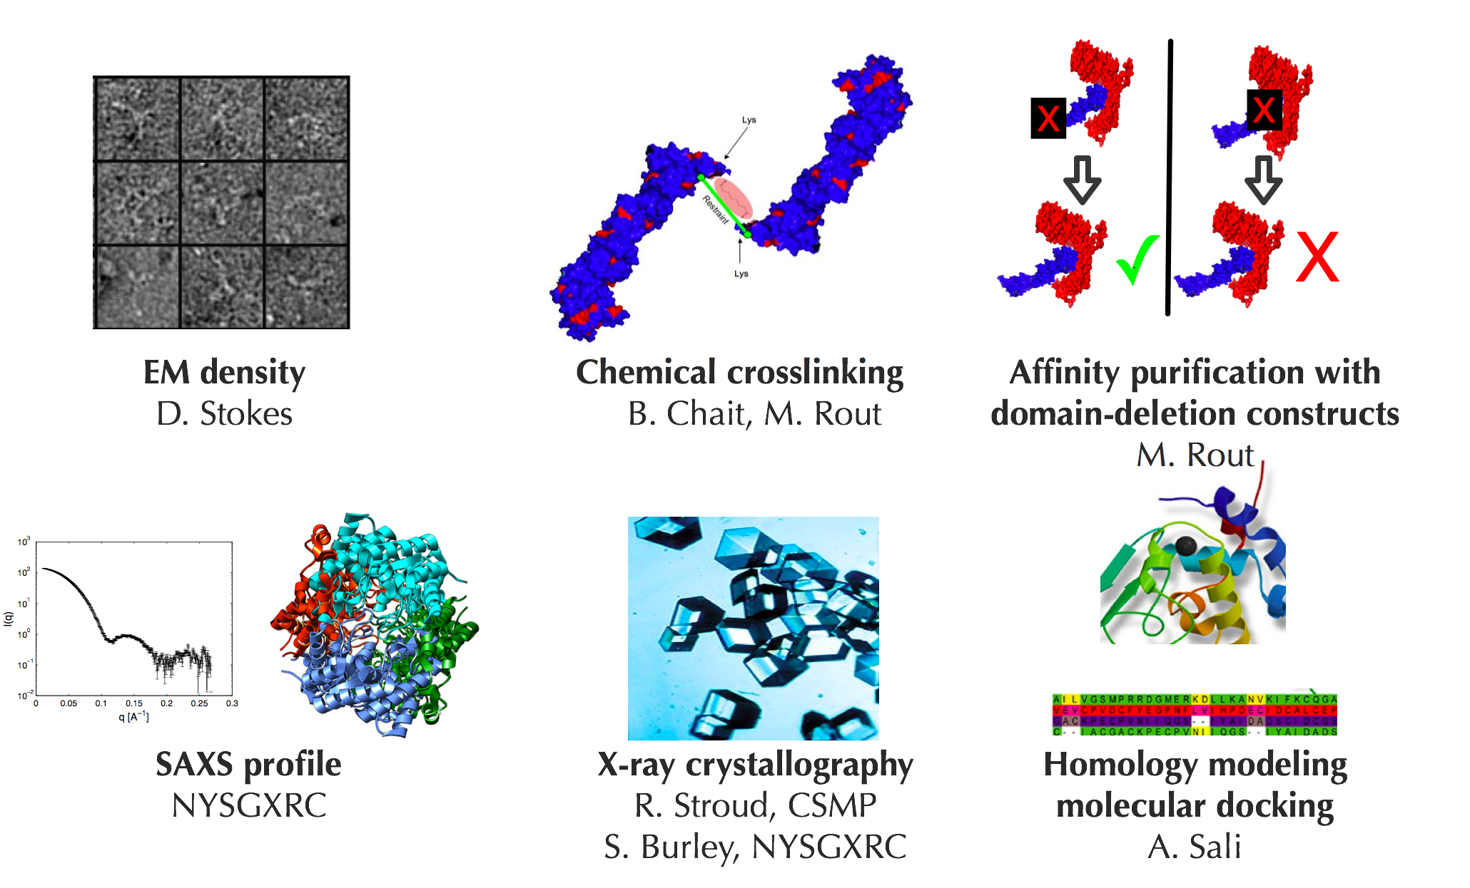
Fig. 9. Determining the pseudo atomic structure of the NPC. The new datasets that will be used in addition to the existing data (Section C.3) are indicated, together with the corresponding investigator who will generate it (see Letters of Collaboration in Program Introduction from R. Stroud and S. Burley; the rest are funded investigators in NCDIR).

- Small angle X-ray scattering. We have already successfully purified many of the nups and nup subcomplexes in high yields, but our collaborators may not be able to generate crystals for all of the proteins. In such cases, we can generate SAXS profiles for individual proteins or subcomplexes in solution, which will provide low-resolution shape information. For each SAXS profile, we will utilize a restraint that scores a structure based on the deviation between the experimental profile and a calculated profile for the structure⁸⁶ (Section C.5).
- Chemical cross-linking: We are currently generating cross-linked variants of the Nup84 subcomplex using a set of lysine-lysine cross-linking reagents. We will use mass spectrometry to determine the cross-linked proteins and residues¹⁰². Distance restraints will be imposed, relying on the comprehensive library of spatial restraints for modeling the cross-linking data (Section D.1.1).
- Affinity purification of domain-deletion constructs. We are generating data from affinity purification experiments in which specific N- or C-terminal nucleoporin domains are truncated, initially for the Nup84 subcomplex. The composition of each of the affinity purification complexes will be determined by mass spectrometry, using standard methods^{6,24}. The data will be converted into conditional restraints on the domain – domain contacts as described above (Section D.1.3, Fig. 8).
- Electron density maps. We are working with David Stokes’ lab at New York University to obtain negative stain electron micrographs for several of the nuclear pore subcomplexes, and already have several thousand images for the Nup84 subcomplex consisting of 7 nups. Such micrographs will be converted into 3D density maps of subcomplexes using standard procedures, based on the conical tilt method, classification, and averaging. If possible, cryo-EM analysis will also be performed. The correlation between the 3D density maps and a model will be used as a spatial restraint^{5,38,75,76,88}.
- Excluded volume restraint. To assure that subunits do not overlap with each other, we will utilize the excluded volume restraint as implemented in IMP. Specifically, a harmonic penalty is imposed if the distance between particles is smaller then the sum of their radii.

Comparative modeling. Additional crystallographic structures determined by our collaborators and others will allow for the generation of reasonably accurate comparative models of most yeast nup proteins or at least their domains. We will use our comparative modeling package MODELLER¹⁷ to build models of all domains or proteins with detectably related known structures.
- Molecular docking. We will computationally dock pairs of interacting nups whose structures have been determined by X-ray crystallography or can be modeled reliably by comparative modeling. We will use program PATCHDOCK, which relies on geometric complementarity to rank a large number of relative orientations^{12,14,106}. For each pair of proteins, the top scoring binding modes will be converted into an XOR restraint (Section D.1.2).
- Comparative patch analysis. Comparative patch analysis is a hybrid of comparative modeling based on a template complex and protein docking⁹³. It expands binding modes of proteins using binding modes of other proteins of the same fold. These modes are then used to restrain conventional molecular docking. We will utilize comparative patch analysis to restrain nup-nup domain interactions according to interactions between similar folds, such as the COPII and clathrin coating complexes^{77,78}.
Representation. We will represent all NPC proteins as full atomic structures, derived from a combination of crystallographic structures and comparative models. For some nucleoporin domains, neither crystal structures nor adequate models may be available. These domains will be represented by chains of beads of varying sizes, as used for our original NPC structure.^{6,24}
Optimization. We will start by solving for the structures of several NPC subcomplexes, beginning with rigid body atomic structures or models of the individual protein subunits. We will take advantage of the optimizers in the DOMINO module of IMP described in Specific Aim 2 (Section D.2) to generate good-scoring solutions. Next, we will use a biased Monte Carlo optimization algorithm with a conjugate gradients optimizer to locally refine each of the solutions. Once we have generated solutions for several NPC subcomplexes, we will combine all restraints and data for the entire NPC to optimize the full structure. We will likely treat some of the subcomplexes as rigid bodies so that interactions between subcomplexes can be appropriately sampled.

Assessing the NPC structure. We will use five distinct criteria to assess the accuracy of a pseudo-atomic NPC structure (Section C.1)¹¹⁴. First, we will assess the self-consistency of the NPC restraints by running our optimization with proteins names in some domain-deletion affinity purification randomly swapped. We will expect to see a single cluster of solutions from the real data, and zero possible solutions where the protein names are incorrectly swapped. Second, we will use a cross-validation scheme; that is, we will repeat our optimization of the NPC several times without a random subset of restraints, and look for consistency with the leftover restraints. Third, we will assess the similarities among solutions that satisfy all restraints; the structural variations define the precision of structure determination. Fourth, we will repeat the structure calculation with simulated restraints to determine the quantity and quality of restraints that are in principle necessary for a successful structure determination³. Finally, we will look for patterns in our structure that would not be expected by chance, such as the close proximity of recent gene duplicates in the NPC molecular architecture.
D.2 Specific Aim 2: Develop methods for sampling static structures of an assembly that optimally satisfy a given set of spatial restraints
To efficiently support the modeling of macromolecular assemblies of interest to us, we need to develop more powerful optimization and sampling methods. Optimization of scoring functions for structure determination of complex biological systems is often in the general class of NP-complete problems (ie, the time complexity increases exponentially with the number of optimized degrees of freedom)¹¹⁵. Increasing the resolution of the assembly representation and the complexity of the scoring function will result in a sampling challenge that cannot be solved efficiently using our existing optimization methods. For example, optimization of the molecular architecture of the NPC took approximately 30 days on 200 CPUs, for a single set of restraints and parameters (Section C.3); during the development and testing of the overall approach, optimization had to be executed many times, resulting in a significant bottleneck for the approach. To determine the pseudo atomic structure of the NPC, we need to increase the resolution of the representation and add additional restraints (Section D.1). Therefore, we need more efficient optimization protocols, even though we don’t necessarily have to start from random configurations, as was the case for the initial study (Section C.3).
Traditional iterative optimizers (such as conjugate gradients and molecular dynamics) optimize all degrees of freedom simultaneously. During each step, the values of the scoring function and its first derivatives are calculated and the values of the degrees of freedom are updated. As the number of degrees of freedom increases, this procedure becomes less efficient. To address this problem, we propose a divide-and-conquer approach. First, the set of degrees of freedom is decomposed into smaller subsets restrained by restraints that are relatively decoupled from those for other subsets. Second, the subsets are optimized independently from each other by a traditional optimizer, producing a number of optimal solutions, one of which should ideally correspond to the globally optimal values. Third, the individual subset solutions are gathered into the best possible solutions for the complete set of degrees of freedom. Graph theory provides efficient algorithms for the first (decomposition) and third steps (gathering)¹¹⁶. Not every optimization problem benefits from this divide-and-conquer approach (eg, it may not be possible to obtain sufficiently decoupled subsets to allow for an efficient gathering), but many of our scoring functions are likely to be amenable. For scoring functions with densely coupled degrees of freedom, we will use approximate solutions for decomposition and gathering. In general, the three steps can be performed iteratively with an increasingly finer discretization of the space of subset solutions, to obtain higher-resolution and more refined global solutions.
We will adopt the graph theory framework for the next generation of our optimization methods and adapt it to the structure determination of macromolecular assemblies by satisfaction of spatial restraints, such as those described in Section D.1. Next, we describe the steps of our divide-and-conquer approach and a benchmark. We will illustrate the approach by two related problems of assembly arrangement: computational docking of multiple subunits (the multiple docking problem)¹¹⁷ and fitting of multiple subunits into a cryo-EM map of the whole assembly (the multiple fitting problem)⁸⁸. In both cases, we are given atomic structures of the individual assembly subunits and our aim is to find their relative positions and orientations. The scoring function contains terms for shape complementarity between pairs of interacting subunits¹¹⁷. In the case of multiple fitting, the scoring function also contains terms quantifying the degree of overlap between each subunit and the cryo-EM map⁸⁸.

D.2.1 Step 1: Decomposition into subsets
We will represent the optimization problem using a graphical model, in particular the factor graph notation¹¹⁸. This representation naturally factors the scoring function into a sum of its individual restraints. Specifically, the nodes of the graph correspond to the subunits (circles) and the restraints (squares), with edges between restraints and the corresponding subunits (Fig. 10).
Given the factor graph representation, we will use the junction tree algorithm¹¹⁶ to attempt to decompose the set of degrees of freedom into smaller subsets that are relatively decoupled from each other, can be easily optimized on their own, and whose individual solutions can be gathered together into a globally optimal solution (below). The efficiency and accuracy of the subset optimizations and gathering depend on the size of the largest subset. For some assembly arrangement problems, the size of the largest subset is not a limiting factor. For example, the size of the largest subset for optimizing the NPC molecular architecture²⁴ is only 10 subunits. The junction tree decomposition was also shown to be efficient for the multiple fitting problem⁸⁸. However, there may be instances of optimization problems for which the junction tree decomposition will result in very large subsets. For example, the multiple docking problem includes interaction terms for all pairs of subunits, possibly resulting in large subsets. In such cases, we will explore approximate decomposition methods^{116,118}.
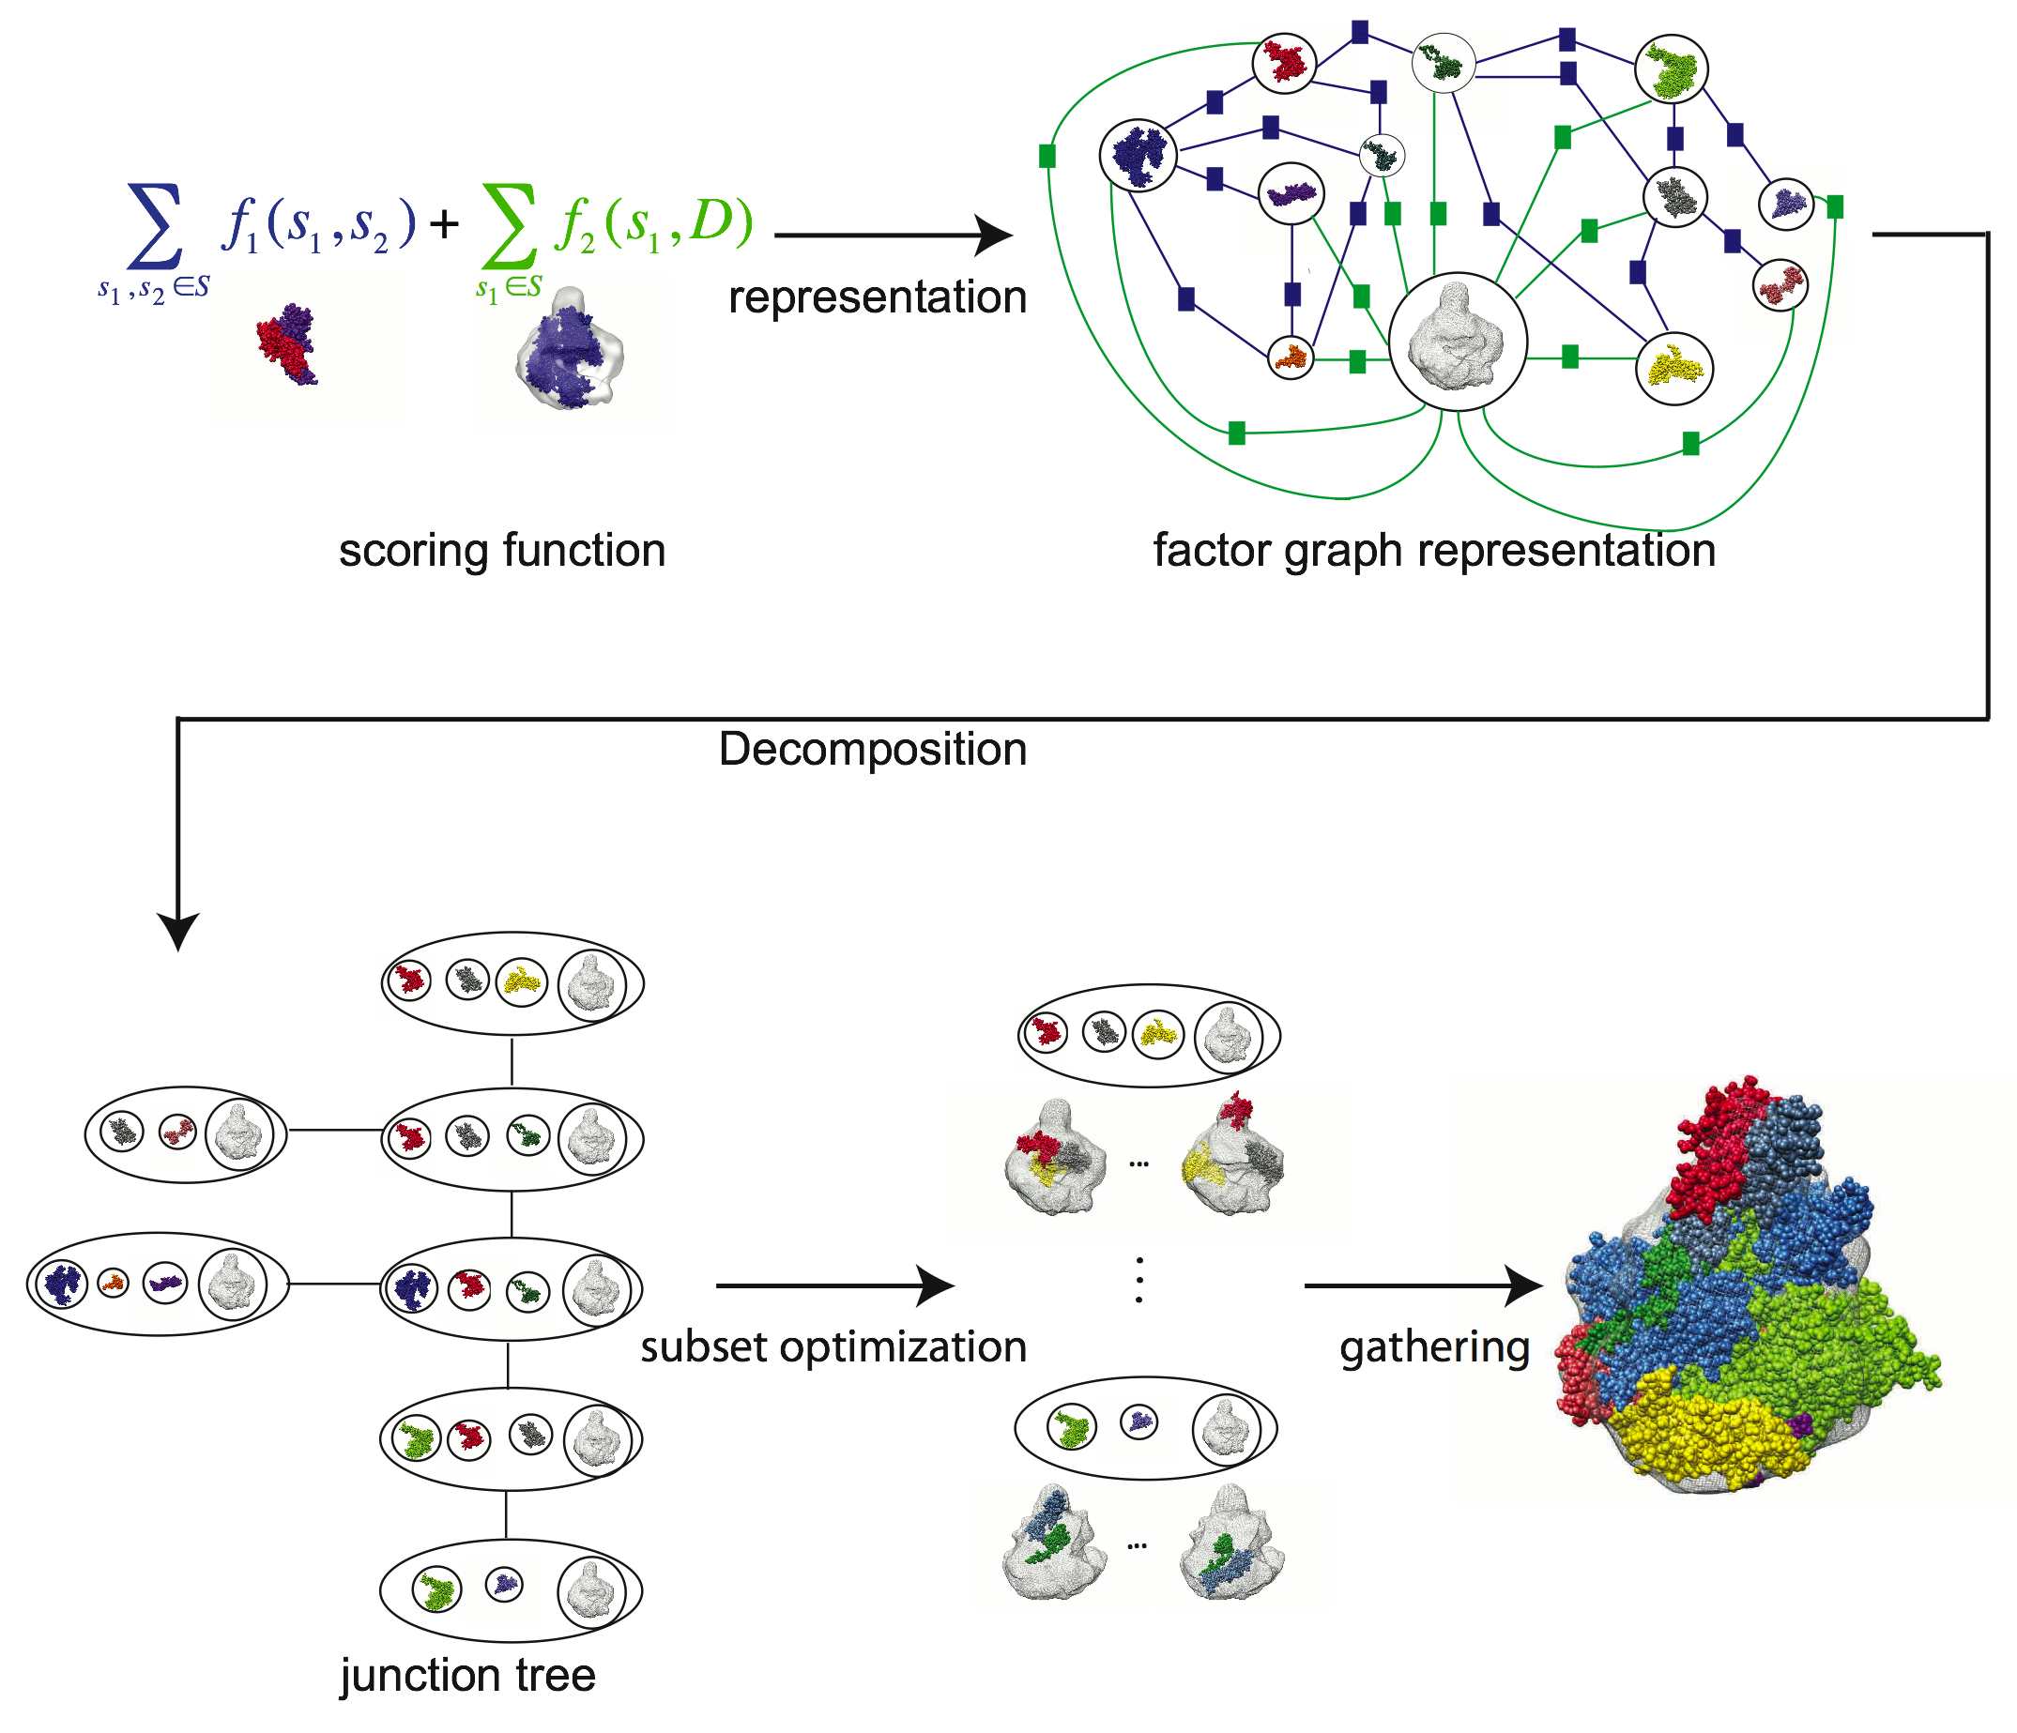
Fig. 10. Graphical representation of the assembly arrangement problem. Multiple fitting of the 12 subunits of the human RNA polymerase II into a cryo-EM map at 20 Å resolution¹¹. The scoring function is a sum of terms quantifying pairwise shape complementarity between interacting components (f₁, blue) and terms quantifying the degree of overlap between the subunits and the map (f₂, green). Once the corresponding factor graph has been generated (representation), the optimization problem is decomposed into 7 independent “smaller” optimization problems (decomposition). The decomposed graph obeys the junction tree properties¹⁵ for a self-consistent assembly solution. The subsets of degrees of freedom are optimized in parallel and independently of each other by traditional optimization methods (subset optimization). Finally, the global optimum over the discrete sampling space spanned by all combinations of individual subset solutions is inferred (gathering).

D.2.2 Step 2: Subset optimization
In this step, we independently solve a small optimization problem for each subset of degrees of freedom and corresponding restraints, resulting in the optimal and nearly optimal solutions for each subset. We will explore various traditional optimizers, such as conjugate gradients⁷⁰, molecular dynamics¹¹⁹, and Monte Carlo¹²⁰, as well as more sophisticated schemes, such as self-guided Langevin dynamics^{71,72} and the replica exchange method⁷³. For example, in the multiple docking problem, the solutions could include the optimal and nearly optimal pairwise binding modes from computational docking¹²¹. In the multiple fitting problem, the solutions could include the optimal and nearly optimal rigid fits of single subunits into the assembly map¹²².
D.2.3 Step 3: Gathering of subsets
We will utilize so-called message-passing algorithms to infer the global optimum (ie, the maximum a posteriori configuration of the factor graph) in the discrete sampling space spanned by all combinations of individual subset solutions. We will start with the “belief propagation” algorithm¹⁵, which seeks the global minimum by iteratively passing messages about the values of degrees of freedom between the subsets of the decomposed factor graph until convergence. This iterative inference algorithm was proved to find the global optimum of the scoring function represented by the factor graph, if the decomposed graphical representation does not contain any cycles (ie, it is a tree). For optimization problems without feasible exact decomposition, we will consider approximate message passing algorithms. For example, the belief propagation algorithm may converge to the global optimum for a cyclic factor graph as well as a tree, but without a guarantee¹²³. We will also explore the use of approximate sampling methods, such as the loopy algorithm¹²³ and Gibbs sampling¹²⁴.
D.2.3 Implementation
The graphical representation and sampling methods will be implemented in the DOMINO (Discrete OptiMization of Interacting Objects) module of IMP. IMP users will be able to use DOMINO optimizers in conjunction with traditional optimizers listed in Section D.2.2, all of which will be implemented in IMP. DOMINO will be used for decomposition and gathering, while the independent subset optimizations will be performed by any of the traditional optimizers in parallel, according to the specifics of the problem.
D.2.4 Benchmark
DOMINO will be evaluated by modeling 10 different assemblies of known structure, in both the multiple fitting and multiple docking scenarios. The input for each test case will be individual atomic structures of assembly subunits and, for the multiple fitting problem, a calculated cryo-EM density map of the assembly. We will explore various methods for graph decomposition, IMP optimizers for subset optimization, as well as exact and approximate inference algorithms for the gathering. The main result will be protocols and rules of thumb that IMP users can apply for choosing the most appropriate tools for their specific assembly optimization problems.

D.3 Specific Aim 3: Develop methods for sampling trajectories of a given macromolecular system that are consistent with input information about its structures and dynamics
We aim to extend our integrative modeling approach to handle the dynamic processes involving macromolecular assemblies. These processes take place over the time scales from nanoseconds to minutes. Bridging the gap between the microsecond time scale, which physical simulations are beginning to reach, and the millisecond time scale where single molecule methods come into play is a major challenge. In fact, no single technique is able to cover the spatial and temporal scales of interest. Therefore, as for the determination of static structures, we need to develop a method that can combine inputs from a wide variety of experimental and theoretical data sources.
First, we discuss our efforts to model transport through the NPC (Section D.3.1). Second, we present our preliminary ideas on a general framework for integrative modeling of dynamics of assemblies (Section D.3.2). In contrast to the work in Section D.3.1 that uses experimental data as input to build a traditional Brownian dynamics simulation, the effort in Section D.3.2 builds a graph-based model of the whole process directly from the data. The methodology developed in Specific Aim 3.2 will be applied to other systems studied in NCDIR, including assembly and component turnover in the NPC, the development of the peroxisome (Core 2, Project 11), chromatin dynamics (Core 2, Projects 5 & 6), and the assembly and export of RNPs (Core 2, Project 8).
D.3.1 Build a model of transport through the NPC that allows us to predict transport rates
We are building a model that will allow us to compute the effect on transport rates of modifications of the NPC, associated karyopherins, and molecules to be transported. Such predictions will allow us to experiment with modifications to the transport process in silico before testing them in vitro or in vivo. Building the model is challenging for at least three reasons. First, transport through the NPC takes place on the scale of milliseconds¹²⁵. Second, we do not know the atomic or even residue level structure of most of the subunits involved. Third, the large number of unstructured domains, cargo, transporters, and contaminant molecules involved in transport make the state space very large and probably prevent using a small set of reaction coordinates. To surmount these challenges, we are building a coarse-grained Brownian dynamics simulation that critically depends on experimental measurements for structural, thermodynamic, and kinetic parameters of the system.
Coarse-grained models generally allow us to tackle systems that are far out of reach of traditional molecular dynamics. A coarse-grained model necessarily blurs out many details of the system, but can still give us valuable insights into the system’s properties. For example, on the static front, the coarse grained-model of the NPC structure produced valuable insights into the evolution and function of the NPC²⁴. On the dynamics front, physically derived coarse-grained models have allowed the modeling of processes beyond what can be done with atomic models¹²⁶⁻¹²⁸.
On a much more simplified level are systems aimed at modeling large numbers of freely diffusing proteins^{55,129}. Such methods have already been applied to the NPC transport¹³⁰, but do not have the required quantitative predictive power. Likewise, approaches based on sampling along a few reaction coordinates¹³¹ cannot satisfy our needs due to, for example, the importance of competition between cargo and contaminants¹³².
Our model extends the flexible bead chain representation of the ordered nups comprising the structure of the NPC²⁴ by adding an explicit coarse-grained representation of the unstructured domains, the molecules that are transported through the nuclear pore, and contaminant molecules that are excluded from transport (Fig. 11). We use Brownian dynamics simulations to determine the dynamics of the resulting model.
We will first present the subunits of our model in more detail and then discuss how we will use data from the literature as well measurements taken by our collaborators (M. Rout and B. Chait) to determine the needed kinetic parameter values. Finally, we will discuss lroadblocks to and experimental testing of the model.
Representation. The NPC ring and the nuclear membrane are represented by a set of approximately 1000 fixed spheres. These balls are placed so that their union approximates the interior of isosurfaces of the density found for the individual nups²⁴. More specifically, these balls are placed using the Powercrust algorithm¹³³ that approximates a volume by placing balls on the medial axis of the interior. We currently chose an isosurface so that the volume enclosed in the isosurface matches the volume for the protein used previously²⁴. To make collision detection more efficient, the NPC ring is covered by a layer of larger spheres that are refined only when determining collisions with nearby objects.

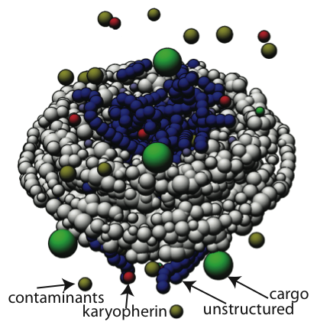

Fig. 11. The NPC transport model. Our model of the NPC consists of five different types of subunits: the NPC ring (gray), unstructured domains (the FG repeats, in blue), karyopherins (which escort preferentially transported cargo, yellow), cargo (green), and non-specifically interacting particles (red), which we call contaminants. Each subunit is represented as one or more connected balls that interact with other subunits of the same or different type either through excluded volume interactions or by forming higher order complexes. The volume simulated in the model has a radius of 250 nm (the diameter of the NPC is approximately 100 nm), allowing us to simulate micromolar concentrations of cargo, contaminants, and karyopherins.
Karyopherins, contaminants, and cargo are represented as single spheres of varying sizes to approximate the volume of the particle in question. Where the structure of the particle is known, we use it to choose the sphere radius. Otherwise we use measured Stokes radii, or failing that, estimate the radius from the mass¹³⁴. For contaminants in the cell, we do not currently have an easy way of choosing the distribution of sizes of the particles. We will discuss below some experiments that will allow us to tune the contaminant size distribution.
Our model appears to be the first computational model that explicitly represents the full set of unstructured domains. Each domain is represented as a polygonal chain with one edge for each 30 residues in the chain. At each stage in the simulation, each link is covered by a variable number of kissing balls. The number of balls is chosen to maintain an approximately constant excluded volume. We list below the kinds of parameters we will use; importantly, such parameters can also be obtained for the complexes studied in the Driving Biological Projects (see examples in Core 1, Project 3).
Interactions. We model the interaction between each pair of types of particles. EV means excluded volume only, AD means that they can associate and dissociate:

 | NPC ring | Unstructured | Karyopherin | Cargo | Contaminant
Contaminant | EV | EV | EV | EV | EV
Cargo | EV | EV | AD | EV
Karyopherin | EV | AD | EV
Unstructured | EV | AD

Each of the terms is a function of the distance between the two spheres, either a harmonic repulsion for the excluded volume case, or a coupling spring for the case of two bonded particles. For the time being, we do not consider the limited number of binding sites on each karyopherin; however, the number of interactions is implicitly limited by the number of objects that can be packed near one another. Limits on the number of interactions can easily be added later.
Associations are represented as springs connecting the associated particles. Each time step unassociated particles are closer than twice the expected diffusion distance, they are associated with a distance dependent probability. Similarly, each pair of associated particles has a fixed probability of becoming disassociated. When they disassociate, the restraining spring between them is removed.
The excluded volume terms are modeled by a harmonic lower bound whose minimum is set to the distance between the balls minus the expected distance the two particles will diffuse in a single time step. The spring constants are determined from fine-grained simulations as discussed below.
Advancing time. We advance time using Brownian dynamics, since we are interested only in long time scales and low-resolution motions when considerations of momentum are unlikely to be of importance. In a Brownian dynamics formulation, the coordinates for the next time step are given by , where δ is the time step, T the temperature, D the diffusion constant for the particle, and R is a normal random variable with standard deviation proportional to the square root of δD.
Finding values for the parameters. Our model requires a variety of parameters. Some of them can be estimated computationally, while others require experimental input. For the latter, we will benefit from our interactions with the Rout and Chait groups.
Experimental determination of simulation parameters. The Rout lab is measuring kinetic constants for various interactions used in the model. Currently, these measurements are limited to the dissociation constant k_{d}. To estimate the association and dissociation rate constants, which are needed to compute the on and off probabilities, we currently assume that the reaction is diffusion limited. Our collaborators will be providing us with direct experimental measurements of the association and dissociation rate constants in the future.
There are four progressively more complex systems related to the NPC for which we have some experimental data. These systems allow us to test various parts of the model as well as search for valid values of the missing parameters.
- Parameters for FG repeats. The parameters for the FG repeats will be derived from measured force extension curves for Nup153¹³⁵. These curves were fit to the worm-like-chain polymer model, generating an analytic model for the force versus extension for a single FG repeat chain. We search for sets of values for the parameters for non-interacting FG repeats, namely the chain bead diffusion coefficient, the chain stretch, the chain equilibrium extension, and the chain-chain repulsion that fit this force extension curve.
- Diffusion rates. The Rout lab has taken measurements of passive diffusion rates of various particles through 30 nm pores. By testing an equivalent version of our computational model, we will test the Brownian dynamics code as well as diffusion coefficients and particle repulsion parameters that reproduce the measured diffusion rate.
- Interactions with FG repeats and karyopherins/contaminants. In conjunction with the previous measurements, the Rout lab has also measured transport rates for various types of particles through pores coated with single types of FG repeats (see examples in Core 1, Project 3). Reproducing this experiment computationally allows us to test the interaction coefficients between both non-interacting particles and the FG repeats as well as karyopherins and the FG repeat chains.
- Background contaminant concentration. Finally, we have measurement data of the transport rate of various sized non-interacting particles through NPCs in the cell. Replicating these experiments allows us to test our model of the background concentration of cargo and contaminants.
These tests of pieces of the model allow us to cover most of the key interactions before making predictions with the whole model.

Computational determination of simulation parameters. We use a combination of experimental measurements and fine-grained simulations to determine values for the various parameters needed by the model. There may be parameters that are guessed. In such a case, we will explore a reasonable range of values to determine if and how is the specific value important for the studied features.
The first set of parameters is the soft sphere repulsion spring constants for each pair of particles. These are determined using short time step simulations of the pair of particles involved. For interactions between structured particles, the spring constants are obtained by fitting a potential of mean force-like potential to the results of the fine time step simulations. For interactions involving unstructured domains, the fine-grained simulations are performed on models with one bead per residue and stiff springs connecting consecutive residues. Such simulations are also used to measure the volume swept out by the chain during a time step to be used for setting the repulsion radius.
In addition to the previously mentioned parameters, Brownian dynamics requires a diffusion constant, D, for each mobile particle. This constant is used to determine the random perturbation applied to each particle as well as to properly scale the motion resulting from the applied force. Since we explicitly model all large subunits of the system, we estimate D for particles from their radius, using the standard expression , where η is the viscosity of water.
We need to use a time step that is small enough to ensure that the forces do not change too much during each time step. We can estimate the maximum time step allowed from the resolution of the force fields involved and the diffusion constants of the particles. Given the coarseness of our model and the smoothing added to the forces by the excluded volume force, a time step of a tenth of a nanosecond is likely to be appropriate. The experimental tests below will allow us to verify this expectation. The simulation code explicitly ensures that forces do not change too much between time steps and that unstructured chains do not pass through one another.

Expectations and testing. The most likely source of problems we may encounter while building the model is that the available data does not uniquely determine the necessary parameters. As in the static assembly case, should our model be under-constrained, we will need to perform more experiments. The behavior of the various solutions is likely to guide what sort of experiments need to be performed.
We will test the model against experimental data as appropriate to ensure its accuracy. We plan on building models of the kinetics of karyopherin cycling through the NPC and, on the other end of the size scale, mRNA export through the NPC. Our models of these processes will be checked against experimental measurements taken by the Rout lab.
D.3.2 Develop a theoretical framework for modeling of assembly dynamics
We propose to extend our formalism of modeling static structures by satisfaction of restraints to dynamic processes. If successful, such an approach will allow us to incorporate more varied sources of data into the modeling process and so handle systems and time scales that are out of reach of even coarse-grained simulations, such as Brownian dynamics simulations described above. As in the static case, this extended formalism has three important parts: how the model is represented, how instances of the model are scored, and how we search for good models. The proposed work is related to the modeling of RNA folding using footprinting data¹³⁶. Methods for this Specific Aim will also be implemented in IMP.
Representation of dynamics models. We will represent a dynamics model as a set of static states connected by directed edges. Such a model is close to typical qualitative descriptions of biological processes in literature^{136,137}. In each static state, each component of the system is represented by a collection of balls (in the highest resolution case, one ball per atom). The spatial resolution (the resolution within each static state) and the temporal resolution (how many static states) of the model can be varied as needed, depending on available data and computational limits. Each edge will have associated rate information and possibly typical trajectories as available. Such a model can be used to compute rates of transitions between various states as well as generate representative (coarse-grained) trajectories. In addition, we expect to be able to model small changes to the system via perturbations to the original graph model, simplifying the job of predicting their effect.
Scoring of dynamics models. A dynamics model can be scored using a wide variety of experimental and theoretical information. On the experimental side, the model can be used to compute the rate of many types of events, such as FRET interactions, overall reaction rates, rate of changes of SAXS curves, followed by comparing the computed rates against the measured ones. Deviations from observations will be penalized restraint terms and their derivatives can be used to guide the search process. In a manner analogous to the connectivity restraint (Fig. 4), the occurrence of interactions or local conformations that have been recorded during the process can be enforced and models lacking them can be penalized. Likewise, on the theoretical side, detailed molecular dynamics trajectories can be used to estimate rates of transitions between states and search for states that can be connected; models that lack predicted interactions between components can be penalized.
Sampling of dynamics models. In principle, the optimization/sampling process for these dynamics models is the same as in the static case: we have a collection of balls embedded in space and a set of restraints on their relative positions. The addition of time makes the problem computationally more difficult due to the extra dimension (states are now packed in 4 dimensions rather than 3). We do not yet know what effect this will have on optimization nor whether we will need to develop new sampling methods to find optimal dynamic models.
D.4 Timetable
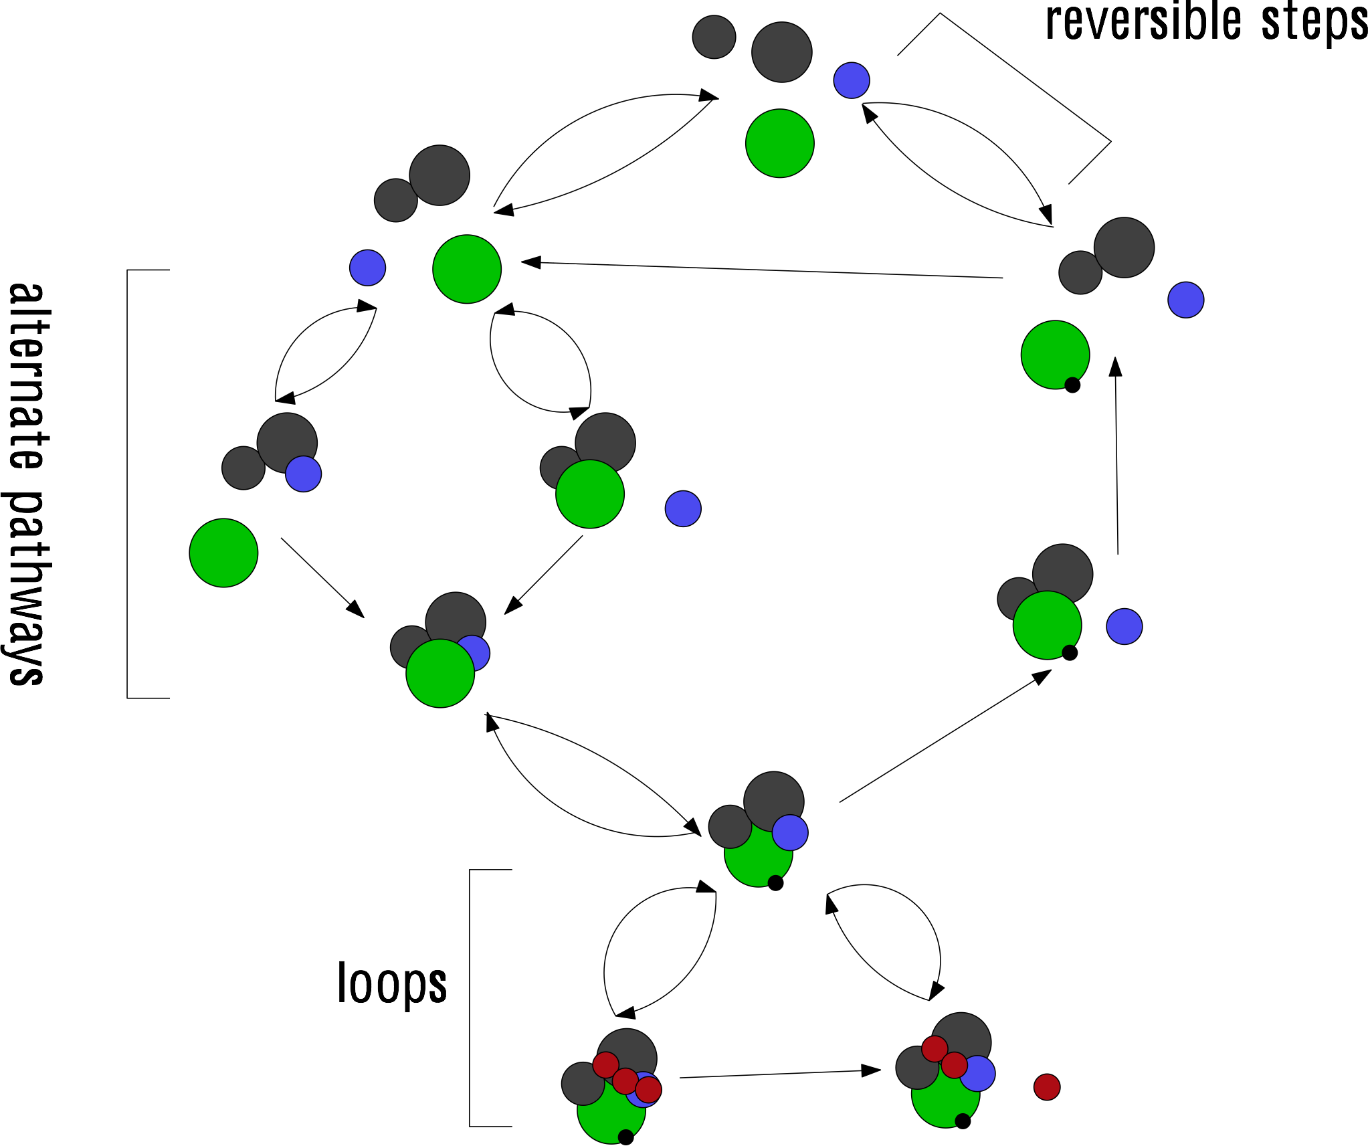
Fig. 12. Trajectory generation as satisfaction of spatial and temporal restraints. A cartoon process is represented as a directed graph of static states. When building such a model, the key questions are: What are the important states to use? How are they connected? What are the transition rates between states? What are the trajectories between states? Once the overall topology of the graph and the general representation for the involved species is chosen, particular models of the process (assignments of positions to species in each state and rates between the states) can be score based on how well they satisfy experimental data.

Specific Aim 1: Preliminary versions of new spatial restraints will be developed and tested in Year 1. They will be tested within the context of pseudo-atomic structure determination of the NPC in Year 2. The restraints will be refined in subsequent years, to reflect their continuous testing and progress on experimental structure characterization of additional complexes, listed in Core 2 (such as the 26S proteasome).
Specific Aim 2: A preliminary version of inferential optimization will be developed and tested in Year 1. It will be tested within the context of pseudo-atomic structure determination of the NPC in Year 2. The optimization protocols will be refined in subsequent years, to reflect their continuous testing and progress on experimental structure characterization of additional complexes, listed in Core 2 (such as 26S proteasome).
Specific Aim 3: A preliminary version of a Brownian dynamics model of transport through the NPC (Aim 3.1) will be largely completed in Year 1. In year 2, we will test specific numerical ranges for most of the key parameters, based on experiment where possible. In subsequent years, we will refine the model and test it experimentally. The alternative method for describing dynamics of macromolecular processes (Aim 3.2) will exist in a draft form in Year 2, and will be refined in subsequent years.
E. HUMAN SUBJECTS
None.

F. VERTEBRATE ANIMALS
None.

G. LITERATURE CITED
¹ Sali, A., Glaeser, R., Earnest, T., & Baumeister, W., From words to literature in structural proteomics. Nature 422 (6928), 216-225 (2003).
² Alber, F., Eswar, N., & Sali, A., Structure determination of macromolecular complexes by experiment and computation in Practical Bioinformatics, edited by J.M. Bujnicki (Springer-Verlag, Germany, 2004), pp. 73-96.
³ Alber, F., Kim, M.F., & Sali, A., Structural characterization of assemblies from overall shape and subcomplex compositions. Structure 13 (3), 435-445 (2005).
⁴ Russell, R.B. et al., A structural perspective on protein-protein interactions. Curr Opin Struct Biol 14 (3), 313-324 (2004).
⁵ Topf, M., Baker, M.L., John, B., Chiu, W., & Sali, A., Structural characterization of components of protein assemblies by comparative modeling and electron cryo-microscopy. J Struct Biol 149 (2), 191-203 (2005).
⁶ Alber, F. et al., Determining the architectures of macromolecular assemblies. Nature 450 (7170), 683-694 (2007).
⁷ Block, S.M., Kinesin motor mechanics: binding, stepping, tracking, gating, and limping. Biophys J 92 (9), 2986-2995 (2007).
⁸ Gelderblom, H.R., Assembly and morphology of HIV: potential effect of structure on viral function. AIDS 5 (6), 617-637 (1991).
⁹ Forster, M.J., Mulloy, B., & Nermut, M.V., Molecular modelling study of HIV p17gag (MA) protein shell utilising data from electron microscopy and X-ray crystallography. J Mol Biol 298 (5), 841-857 (2000).
¹⁰ Berthet-Colominas, C. et al., The crystal structure of asparaginyl-tRNA synthetase from Thermus thermophilus and its complexes with ATP and asparaginyl-adenylate: the mechanism of discrimination between asparagine and aspartic acid. EMBO J 17 (10), 2947-2960 (1998).
¹¹ Kostek, S.A. et al., Molecular architecture and conformational flexibility of human RNA polymerase II. Structure 14 (11), 1691-1700 (2006).
¹² Duhovny, D., Nussinov, R., & Wolfson, H.J., presented at the Second International Workshop on Algorithms in Bioinformatics Italy, 2002 (unpublished).
¹³ Schneidman-Duhovny, D., Inbar, Y., Nussinov, R., & Wolfson, H.J., Geometry-based flexible and symmetric protein docking. Proteins 60 (2), 224-231 (2005).
¹⁴ Schneidman-Duhovny, D. et al., Taking geometry to its edge: fast unbound rigid (and hinge-bent) docking. Proteins 52 (1), 107-112 (2003).
¹⁵ Pearl, J., Probabilistic Reasoning in Intelligent Systems : Networks of Plausible Inference. (Morgan Kaufmann, 1988).
¹⁶ Gao, H. et al., Study of the structural dynamics of the E coli 70S ribosome using real-space refinement. Cell 113 (6), 789-801 (2003).
¹⁷ Sali, A. & Blundell, T.L., Comparative protein modelling by satisfaction of spatial restraints. J Mol Biol 234 (3), 779-815 (1993).
¹⁸ Xu, Z., Horwich, A.L., & Sigler, P.B., The crystal structure of the asymmetric GroEL-GroES-(ADP)7 chaperonin complex. Nature 388 (6644), 741-750 (1997).
¹⁹ Sali, A. & Kuriyan, J., Challenges at the frontiers of structural biology. Trends Cell Biol 9 (12), M20-24 (1999).
²⁰ Sali, A., NIH workshop on structural proteomics of biological complexes. Structure 11 (9), 1043-1047 (2003).
²¹ Stock, D., Leslie, A.G., & Walker, J.E., Molecular architecture of the rotary motor in ATP synthase. Science 286 (5445), 1700-1705 (1999).
²² Ilari, A. & Savino, C., Protein structure determination by x-ray crystallography. Methods Mol Biol 452, 63-87 (2008).
²³ Jones, C.J. & Aizawa, S., The bacterial flagellum and flagellar motor: structure, assembly and function. Adv Microb Physiol 32, 109-172 (1991).
²⁴ Alber, F. et al., The molecular architecture of the nuclear pore complex. Nature 450 (7170), 695-701 (2007).
²⁵ Amero, C.D., Boomershine, W.P., Xu, Y., & Foster, M., Solution Structure of Pyrococcus furiosus RPP21, a Component of the Archaeal RNase P Holoenzyme, and Interactions with Its RPP29 Protein Partner. Biochemistry (2008).
²⁶ Putnam, C.D., Hammel, M., Hura, G.L., & Tainer, J.A., X-ray solution scattering (SAXS) combined with crystallography and computation: defining accurate macromolecular structures, conformations and assemblies in solution. Quarterly Reviews of Biophysics 40, 191-285 (2007).
²⁷ Strambio-de-Castillia, C., Tetenbaum-Novatt, J., Imai, B.S., Chait, B.T., & Rout, M.P., A method for the rapid and efficient elution of native affinity-purified protein A tagged complexes. J Proteome Res 4 (6), 2250-2256 (2005).
²⁸ Chien, C.T., Bartel, P.L., Sternglanz, R., & Fields, S., The two-hybrid system: a method to identify and clone genes for proteins that interact with a protein of interest. Proc Natl Acad Sci U S A 88 (21), 9578-9582 (1991).
²⁹ Leavitt, S. & Freire, E., Direct measurement of protein binding energetics by isothermal titration calorimetry. Curr Opin Struct Biol 11 (5), 560-566 (2001).
³⁰ Loizos, N., Mapping protein-ligand interactions by hydroxyl-radical protein footprinting. Methods Mol Biol 261, 199-210 (2004).
³¹ Rappsilber, J., Siniossoglou, S., Hurt, E.C., & Mann, M., A generic strategy to analyze the spatial organization of multi-protein complexes by cross-linking and mass spectrometry. Anal Chem 72 (2), 267-275 (2000).
³² Cardullo, R.A., Theoretical principles and practical considerations for fluorescence resonance energy transfer microscopy. Methods Cell Biol 81, 479-494 (2007).
³³ Kopp, J., Bordoli, L., Battey, J.N., Kiefer, F., & Schwede, T., Assessment of CASP7 predictions for template-based modeling targets. Proteins 69 Suppl 8, 38-56 (2007).
³⁴ Lensink, M.F., Méndez, R., & Wodak, S.J., Docking and scoring protein complexes: CAPRI 3rd Edition. Proteins 69, 704-718 (2007).
³⁵ Billinge, S.J. & Levin, I., The problem with determining atomic structure at the nanoscale. Science 316 (5824), 561-565 (2007).
³⁶ Beckmann, R. et al., Architecture of the protein-conducting channel associated with the translating 80S ribosome. Cell 107 (3), 361-372 (2001).
³⁷ Spahn, C.M. et al., Structure of the 80S ribosome from Saccharomyces cerevisiae--tRNA-ribosome and subunit-subunit interactions. Cell 107 (3), 373-386 (2001).
³⁸ Topf, M. & Sali, A., Combining electron microscopy and comparative protein structure modeling. Curr Opin Struct Biol 15 (5), 578-585 (2005).
³⁹ Fiser, A., Do, R.K., & Sali, A., Modeling of loops in protein structures. Protein Sci 9 (9), 1753-1773 (2000).
⁴⁰ Fiser, A., Feig, M., Brooks, C.L., 3rd, & Sali, A., Evolution and physics in comparative protein structure modeling. Acc Chem Res 35 (6), 413-421 (2002).
⁴¹ Baldwin, R.L., Protein folding. Matching speed and stability. Nature 369 (6477), 183-184 (1994).
⁴² Talkington, M.W., Siuzdak, G., & Williamson, J.R., An assembly landscape for the 30S ribosomal subunit. Nature 438 (7068), 628-632 (2005).
⁴³ Treuille, A., McNamara, A., Popovi\, Z., \#263, & Stam, J. Keyframe control of smoke simulations in ACM SIGGRAPH 2003 Papers (ACM, San Diego, California, 2003).
⁴⁴ Latombe, J.-c. Motion Planning: A Journey of Robots, Molecules, Digital Actors, and Other Artifacts (unknown, 1999).
⁴⁵ Agarwal, P.K. et al., Algorithmic issues in modeling motion. ACM Comput. Surv. 34 (4), 550-572 (2002).
⁴⁶ MacNamara, S., Burrage, K., & Sidje, R.B., Multiscale Modeling of Chemical Kinetics via the Master Equation. Multiscale Modeling & Simulation 6 (4), 1146-1168 (2008).
⁴⁷ Brooks, C.L., Karplus, M., & Pettitt, B.M., Proteins: A Theoretical Perspective of Dynamics, Structure, and Thermodynamics. (Wiley, 1988).
⁴⁸ Vasquez, V. et al., Three-dimensional architecture of membrane-embedded MscS in the closed conformation. J Mol Biol 378 (1), 55-70 (2008).
⁴⁹ Trabuco, L.G., Villa, E., Mitra, K., Frank, J., & Schulten, K., Flexible fitting of atomic structures into electron microscopy maps using molecular dynamics. Structure 16 (5), 673-683 (2008).
⁵⁰ Sotomayor, M. & Schulten, K., The allosteric role of the Ca2+ switch in adhesion and elasticity of C-cadherin. Biophys J 94 (12), 4621-4633 (2008).
⁵¹ Lim, B.B., Lee, E.H., Sotomayor, M., & Schulten, K., Molecular basis of fibrin clot elasticity. Structure 16 (3), 449-459 (2008).
⁵² Isin, B., Schulten, K., Tajkhorshid, E., & Bahar, I., Mechanism of signal propagation upon retinal isomerization: insights from molecular dynamics simulations of rhodopsin restrained by normal modes. Biophys J 95 (2), 789-803 (2008).
⁵³ Freddolino, P.L., Liu, F., Gruebele, M., & Schulten, K., Ten-microsecond molecular dynamics simulation of a fast-folding WW domain. Biophys J 94 (10), L75-77 (2008).
⁵⁴ Yu, J., Ha, T., & Schulten, K., How directional translocation is regulated in a DNA helicase motor. Biophys J 93 (11), 3783-3797 (2007).
⁵⁵ McGuffee, S.R. & Elcock, A.H., Atomically detailed simulations of concentrated protein solutions: the effects of salt, pH, point mutations, and protein concentration in simulations of 1000-molecule systems. J Am Chem Soc 128 (37), 12098-12110 (2006).
⁵⁶ Elber, R., A milestoning study of the kinetics of an allosteric transition: atomically detailed simulations of deoxy Scapharca hemoglobin. Biophys J 92 (9), L85-87 (2007).
⁵⁷ Krukenberg, K.A., Forster, F., Rice, L.M., Sali, A., & Agard, D.A., Multiple conformations of E. coli Hsp90 in solution: insights into the conformational dynamics of Hsp90. Structure 16 (5), 755-765 (2008).
⁵⁸ Serysheva, II et al., Subnanometer-resolution electron cryomicroscopy-based domain models for the cytoplasmic region of skeletal muscle RyR channel. Proc Natl Acad Sci U S A 105 (28), 9610-9615 (2008).
⁵⁹ Frank, J., Single-particle imaging of macromolecules by cryo-electron microscopy. Annu Rev Biophys Biomol Struct 31, 303-319 (2002).
⁶⁰ Fiaux, J., Bertelsen, E.B., Horwich, A.L., & Wuthrich, K., NMR analysis of a 900K GroEL GroES complex. Nature 418 (6894), 207-211 (2002).
⁶¹ Young, M.M. et al., High throughput protein fold identification by using experimental constraints derived from intramolecular cross-links and mass spectrometry. Proc Natl Acad Sci U S A 97 (11), 5802-5806 (2000).
⁶² Hernandez, H. & Robinson, C.V., Determining the stoichiometry and interactions of macromolecular assemblies from mass spectrometry. Nat Protoc 2 (3), 715-726 (2007).
⁶³ Phizicky, E., Bastiaens, P.I., Zhu, H., Snyder, M., & Fields, S., Protein analysis on a proteomic scale. Nature 422 (6928), 208-215 (2003).
⁶⁴ Lakey, J.H. & Raggett, E.M., Measuring protein-protein interactions. Curr Opin Struct Biol 8 (1), 119-123 (1998).
⁶⁵ Aebersold, R. & Mann, M., Mass spectrometry-based proteomics. Nature 422 (6928), 198-207 (2003).
⁶⁶ Gray, J.J. et al., Protein-protein docking with simultaneous optimization of rigid-body displacement and side-chain conformations. J Mol Biol 331 (1), 281-299 (2003).
⁶⁷ Aloy, P. & Russell, R.B., InterPreTS: protein interaction prediction through tertiary structure. Bioinformatics 19 (1), 161-162 (2003).
⁶⁸ Valencia, A. & Pazos, F., Computational methods for the prediction of protein interactions. Curr Opin Struct Biol 12 (3), 368-373 (2002).
⁶⁹ Russel, D. et al. IMP: A platform for integrative modeling of structure and dynamics (2008).
⁷⁰ Shanno, D.F. & Phua, K.H., Minimization of Unconstrained Multivariate Functions. ACM Transactions on Mathematical Software 6 (4), 5 (1980).
⁷¹ Wu, X. & Brooks, B.R., Self-guided Langevin dynamics simulation method. 381 381, 512-518 (2003).
⁷² Wu, G., Fiser, A., ter Kuile, B., Sali, A., & Muller, M., Convergent evolution of Trichomonas vaginalis lactate dehydrogenase from malate dehydrogenase. Proc Natl Acad Sci U S A 96 (11), 6285-6290 (1999).
⁷³ Sugita, Y. & Okamoto, Y., Replica-exchange molecular dynamics method for protein folding. Chem. Phys. Lett. 314 (314), 141-151 (1999).
⁷⁴ Brunger, A.T., Assessment of phase accuracy by cross validation: the free R value. Methods and applications. Acta Crystallogr D Biol Crystallogr 49 (Pt 1), 24-36 (1993).
⁷⁵ Topf, M., Baker, M.L., Marti-Renom, M.A., Chiu, W., & Sali, A., Refinement of protein structures by iterative comparative modeling and CryoEM density fitting. J Mol Biol 357 (5), 1655-1668 (2006).
⁷⁶ Topf, M. et al., Protein structure fitting and refinement guided by cryo-EM density. Structure 16 (2), 295-307 (2008).
⁷⁷ Devos, D. et al., Components of coated vesicles and nuclear pore complexes share a common molecular architecture. PLoS Biol 2 (12), e380 (2004).
⁷⁸ Devos, D. et al., Simple fold composition and modular architecture of the nuclear pore complex. Proc Natl Acad Sci U S A 103 (7), 2172-2177 (2006).
⁷⁹ Lim, R.Y. & Fahrenkrog, B., The nuclear pore complex up close. Curr Opin Cell Biol 18 (3), 342-347 (2006).
⁸⁰ Yang, Q., Rout, M.P., & Akey, C.W., Three-dimensional architecture of the isolated yeast nuclear pore complex: functional and evolutionary implications. Mol Cell 1 (2), 223-234 (1998).
⁸¹ Nagata, T. et al., Immunoglobulin motif DNA recognition and heterodimerization of the PEBP2/CBF Runt domain. Nat Struct Biol 6 (7), 615-619 (1999).
⁸² Chance, M.R. et al., High-throughput computational and experimental techniques in structural genomics. Genome Res 14 (10B), 2145-2154 (2004).
⁸³ Chandramouli, P. et al., The canine 80S ribosome-channel complex. (Submitted) (2007).
⁸⁴ Schmid, M.F., Sherman, M.B., Matsudaira, P., & Chiu, W., Structure of the acrosomal bundle. Nature 431 (7004), 104-107 (2004).
⁸⁵ Cong, Y. et al., Crystallographic conformers of actin in a biologically active bundle of filaments. J Mol Biol 375 (2), 331-336 (2008).
⁸⁶ Forster, F. et al., Integration of Small-Angle X-Ray Scattering Data into Structural Modeling of Proteins and Their Assemblies. J Mol Biol 382 (4), 1089-1106 (2008).
⁸⁷ Booth, C.R. et al., Mechanism of lid closure in the eukaryotic chaperonin TRiC/CCT. Nat Struct Mol Biol 15 (7), 746-753 (2008).
⁸⁸ Lasker, K., Topf, M., Sali, A., & Wolfson, H.J., Inferential optimization for fitting multiple components into a cryoEM map of their assembly. J Mol Biol in press (2008).
⁸⁹ Davis, F.P. & Sali, A., PIBASE: a comprehensive database of structurally defined protein interfaces. Bioinformatics 21 (9), 1901-1907 (2005).
⁹⁰ Henrick, K. & Thornton, J.M., PQS: a protein quaternary structure file server. Trends Biochem Sci 23 (9), 358-361 (1998).
⁹¹ Davis, F.P. et al., Protein complex compositions predicted by structural similarity. Nucleic Acids Res 34 (10), 2943-2952 (2006).
⁹² Korkin, D., Davis, F.P., & Sali, A., Localization of protein-binding sites within families of proteins. Protein Sci 14 (9), 2350-2360 (2005).
⁹³ Korkin, D. et al., Structural modeling of protein interactions by analogy: application to PSD-95. PLoS Comput Biol 2 (11), e153 (2006).
⁹⁴ Kim, M.F., Webb, B., & Sali, A. Modular assessment of protein structure modeling methods. (2008).
⁹⁵ Korkin, D. et al., Configuration of homologous subunits in protein assemblies: Application to TriC/CCT chaperonin. (In preparation) (2008).
⁹⁶ Kim, M.F., Sali, A., Dötsch, V., & Reese, M.L., Docking protein complexes using residue content derived from NMR spectroscopy. (In preparation) (2008).
⁹⁷ Sinz, A., Chemical cross-linking and mass spectrometry for mapping three-dimensional structures of proteins and protein complexes. J Mass Spectrom 38 (12), 1225-1237 (2003).
⁹⁸ Sinz, A. & Wang, K., Mapping protein interfaces with a fluorogenic cross-linker and mass spectrometry: application to nebulin-calmodulin complexes. Biochemistry 40 (26), 7903-7913 (2001).
⁹⁹ Dihazi, G.H. & Sinz, A., Mapping low-resolution three-dimensional protein structures using chemical cross-linking and Fourier transform ion-cyclotron resonance mass spectrometry. Rapid Commun Mass Spectrom 17 (17), 2005-2014 (2003).
¹⁰⁰ Pearson, A.R. et al., The crystal structure of cytochrome P460 of Nitrosomonas europaea reveals a novel cytochrome fold and heme-protein cross-link. Biochemistry 46 (28), 8340-8349 (2007).
¹⁰¹ Pimenova, T. et al., Epitope mapping on bovine prion protein using chemical cross-linking and mass spectrometry. J Mass Spectrom 43 (2), 185-195 (2008).
¹⁰² Trester-Zedlitz, M. et al., A modular cross-linking approach for exploring protein interactions. J Am Chem Soc 125 (9), 2416-2425 (2003).
¹⁰³ Brooks, B.R. et al., CHARMM: A Program for Macromolecular Energy, Minimization, and Dynamics Calculations. Journal of Computational Chemistry 4, 187-217 (1983).
¹⁰⁴ Novak, P., Young, M.M., Schoeniger, J.S., & Kruppa, G.H., A top-down approach to protein structure studies using chemical cross-linking and Fourier transform mass spectrometry. Eur J Mass Spectrom (Chichester, Eng) 9 (6), 623-631 (2003).
¹⁰⁵ Comeau, S.R., Gatchell, D.W., Vajda, S., & Camacho, C.J., ClusPro: a fully automated algorithm for protein-protein docking. Nucleic Acids Res 32 (Web Server issue), W96-99 (2004).
¹⁰⁶ Schneidman-Duhovny, D., Inbar, Y., Nussinov, R., & Wolfson, H.J., PatchDock and SymmDock: servers for rigid and symmetric docking. Nucleic Acids Res 33 (Web Server issue), W363-367 (2005).
¹⁰⁷ Chen, R., Li, L., & Weng, Z., ZDOCK: an initial-stage protein-docking algorithm. Proteins 52 (1), 80-87 (2003).
¹⁰⁸ Shoichet, B.K., McGovern, S.L., Wei, B., & Irwin, J.J., Lead discovery using molecular docking. Curr Opin Chem Biol 6 (4), 439-446 (2002).
¹⁰⁹ Lyskov, S. & Gray, J.J., The RosettaDock server for local protein-protein docking. Nucleic Acids Res 36 (Web Server issue), W233-238 (2008).
¹¹⁰ Berke, I.C., Boehmer, T., Blobel, G., & Schwartz, T.U., Structural and functional analysis of Nup133 domains reveals modular building blocks of the nuclear pore complex. J Cell Biol 167 (4), 591-597 (2004).
¹¹¹ Boehmer, T., Jeudy, S., Berke, I.C., & Schwartz, T.U., Structural and functional studies of Nup107/Nup133 interaction and its implications for the architecture of the nuclear pore complex. Mol Cell 30 (6), 721-731 (2008).
¹¹² Hsia, K.C., Stavropoulos, P., Blobel, G., & Hoelz, A., Architecture of a coat for the nuclear pore membrane. Cell 131 (7), 1313-1326 (2007).
¹¹³ Fath, S., Mancias, J.D., Bi, X., & Goldberg, J., Structure and organization of coat proteins in the COPII cage. Cell 129 (7), 1325-1336 (2007).
¹¹⁴ Alber, F., Forster, F., Korkin, D., Topf, M., & Sali, A., Integrating diverse data for structure determination of macromolecular assemblies. Annu Rev Biochem 77, 443-477 (2008).
¹¹⁵ Wales, D.J. & Scheraga, H.A., Global Optimization of Clusters, Crystals, and Biomolecules. Science 285 (5432), 1368-1372 (1999).
¹¹⁶ Jordan, M.I., Learning in graphical models. (MIT Press, Cambridge, Mass., 1999).
¹¹⁷ Inbar, Y. et al., Approaching the CAPRI challenge with an efficient geometry-based docking. Proteins 60 (2), 217-223 (2005).
¹¹⁸ Kschischang, F., Frey, B., & Loeliger, H., Factor graphs and the sum-product algorithm. IEEE Trans. Inform. Theory 47, 498-519 (2001).
¹¹⁹ MacKerell, A.D. et al., All-atom empirical potential for molecular modelling and dynamics studies of proteins. J. Chem. Phys. 102 (102), 3586-3616 (1998).
¹²⁰ Andrew, R., Randomization, Bootstrap and Monte Carlo Methods in Biology. (Royal Statistical Society, 2007).
¹²¹ Halperin, I., Ma, B., Wolfson, H., & Nussinov, R., Principles of docking: An overview of search algorithms and a guide to scoring functions. Proteins 47 (4), 409-443 (2002).
¹²² Fabiola, F. & Chapman, M.S., Fitting of high-resolution structures into electron microscopy reconstruction images. Structure 13 (3), 389-400 (2005).
¹²³ Murphy, K., Weiss, Y., & Jordan, M., Loopy belief propagation for approximate inference: An empirical study in In Proceedings of Uncertainty in AI (1999), pp. 467-475.
¹²⁴ Tatikonda, S.C. & Jordan, M.I., Loopy belief propagation and Gibbs measures in In Uncertainty in Artificial Intelligence (Morgan Kaufmann, 2002), pp. 493-500.
¹²⁵ Kubitscheck, U. et al., Nuclear transport of single molecules: dwell times at the nuclear pore complex. J Cell Biol 168 (2), 233-243 (2005).
¹²⁶ Noid, W.G. et al., The multiscale coarse-graining method. I. A rigorous bridge between atomistic and coarse-grained models. J Chem Phys 128 (24), 244114 (2008).
¹²⁷ Arkhipov, A., Yin, Y., & Schulten, K., Four-scale description of membrane sculpting by BAR domains. Biophys J 95 (6), 2806-2821 (2008).
¹²⁸ Berkowitz, M. & McCammon, J.A., Brownian motion of a system of coupled harmonic oscillators. The Journal of Chemical Physics 75 (2), 957-961 (1981).
¹²⁹ Kerr, R. et al., Fast Monte Carlo simulation methods for biological reaction-diffusion systems in solution and on surfaces. SIAM (2008).
¹³⁰ Zilman, A., Di Talia, S., Chait, B.T., Rout, M.P., & Magnasco, M.O., Efficiency, selectivity, and robustness of nucleocytoplasmic transport. PLoS Comput Biol 3 (7), e125 (2007).
¹³¹ Lielsen, B., Jeppesen, C., & Ipsen, J., Managing free-energy barriers in nuclear pore transport. Journal of Biological Physics 32 (5), 465-472 (2004).
¹³² Jovanovic-Talisman, T. et al., Artificial nanopores that mimic the transport selectivity
of the nuclear pore complex. Nature (in press) (2008).
¹³³ Amenta, N., Choi, S., & Kolluri, R.K., The power crust, unions of balls and the medial axis transform. Computational Geometry 19 (2-3), 127-153 (2001).
¹³⁴ Fischer, H., Polikarpov, I., & Craievich, A.F., Average protein density is a molecular-weight-dependent function. Protein Sci 13 (10), 2825-2828 (2004).
¹³⁵ Lim, R.Y. et al., Nanomechanical basis of selective gating by the nuclear pore complex. Science 318 (5850), 640-643 (2007).
¹³⁶ Laederach, A., Shcherbakova, I., Liang, M.P., Brenowitz, M., & Altman, R.B., Local kinetic measures of macromolecular structure reveal partitioning among multiple parallel pathways from the earliest steps in the folding of a large RNA molecule. J Mol Biol 358 (4), 1179-1190 (2006).
¹³⁷ Marshall, R.A., Aitken, C.E., Dorywalska, M., & Puglisi, J.D., Translation at the single-molecule level. Annu Rev Biochem 77, 177-203 (2008).

H. CONSORTIUM/CONTRACTUAL ARRANGEMENTS
See Program Introduction.

I. RESOURCE SHARING
See Core 3 and Core 5 for a full discussion of resource sharing.

J. LETTERS OF SUPPORT
See Program Introduction for Letters of Support.

